The Inner Workings of the Secret Histories Engine

*Cultist Simulator and the Secret Histories are (c) 2018-2023 Weather Factory. All material from them here is used by permission.*

# Introduction

## Preface

If you’re reading this guide, it probably means that you’re interested in making mods for Cultist Simulator. This document was compiled by several modders in the community who felt that the resources available to learn modding were, at the time of writing, outdated and often inadequate. Although there is good mod support for Cultist Simulator, the process of writing mods can be tricky and often requires a lot of guesswork and problem solving. This makes the barrier for entry to modding rather high, especially for people without a background in computer science.

This guide is meant to provide up-to-date information to help people make mods with as few difficulties as possible, as well as understanding better “how to do” things, or how things already work inside the game. We hope that it can act as both a learning tool and a reservoir of knowledge for aspiring modders.

## What section to read

Based on what you want:

* “Know how to start modding”: read the “Your First Mod” section, explaining the structure of a mod
* “Know the properties of something”: read the “Building Blocks of Cultist Simulator” reference
* “Know how something is done in the game”: read the “How stuff works” section

## Contributors

Just A Stranger (aka justastranger#4169), Kalofinx (aka Rossendale#2875), Joshua (aka superjw2#3378), Multi#0897, Genroa (Genroa#9042), Chelnoque, SarahK, Xardis

## 

## Contents

**Introduction 1**

Preface 1

What section to read 1

Contributors 2

Contents 3

**Your First Mod 10**

Introduction 10

What a mod can and cannot do 10

Where to write/put local mods/mods you're writing 10

Structure of a mod 11

Overview of the folder itself 11

Aside: How images work 11

What tools to use to make mods 12

General concepts 12

Sample mod: Chi Explores the City (and ascends by mistake) 14

Step 0: Setting up the mod 15

Step 1: A new legacy 15

Step 2: The Start 17

Step 3: Simple action: asking for food and cuddles. 20

Step 4: Getting the Explore Verb 22

Step 4.5: Letting Chi explore with the Explore Verb 26

Step 5: A more complex action: looking for cat-treasures in the city 27

Step 6: Chi ascends (somehow) 32

Bonus Step 7: Alternative recipes: give food to ask for the help of the other cats of the city 35

**Building Blocks of Cultist Simulator 36**

Content Format 36

Modifying Base-Game Resources 36

Merge-Overwriting 36

Overwriting 37

Property Operations 37

Dictionaries 38

Lists 38

Values 40

Strings 40

Property agnostic operations 40

Entity level property operations 41

Full Reference 43

🐓 About the Bird 43

📖 About the Book 43

Elements 45

Description 45

Properties of all Elements 46

Element ID 46

Label 47

Description 48

Is It an Aspect? 49

Icon ("icon") 50

Induces ("induces") 50

Decay Element ("decayTo") 50

Verb Icon ("verbicon") 51

XTriggers 51

What xtriggers are 51

Syntax 51

Xtrigger effect types 52

Subtleties of the system: how quantities act and other gotchas 60

How quantities affect the reaction 60

Xtriggers defined on aspects 62

Order of evaluation 62

Achievements 62

Properties specific to Aspects 63

Hidden (“isHidden”) 63

No Art Needed ("noArtNeeded") 63

Properties specific to Cards 63

Aspects ("aspects") 63

Lifetime ("lifetime") 63

Resaturate ("resaturate") 64

Slots ("slots") 64

Hidden ("isHidden") 64

Unique ("unique") 65

Uniqueness Group ("uniquenessgroup") 65

📖 Unlock Codex Entries 65

📖 Remove Codex Entries 65

📖 Update Codex Entries 65

Examples 66

Decks 66

Properties of Decks 68

Slot ID 68

Label 68

Description 69

Reset on Exhaustion 69

Spec (list of cards) 70

Default Card 70

Draw Messages 71

🐓 Shuffle after draw 71

Recipes 72

Description 72

Order of Effects 72

Properties of Recipes 73

Recipe ID 73

Action ID 74

Craftable (can it be started manually by the player?) 75

Maximum Number of Executions 75

Hint Only? 76

Warmup Time 77

Label 78

Slots 79

Start Description 80

Description 81

Requirements 82

Table Requirements 84

Extant Requirements 85

Effects 86

Purge 87

Aspects 88

Deck Effects 89

Halt Verb 90

Delete Verb 91

Internal Deck 92

Signal Important Loop 92

Ending 93

Signal Ending Flavour 93

Achievements 94

Burn Image 94

Portal Effect 95

Mutations 96

Linked Recipes 97

Induced Recipes 99

Alternative Recipes 101

Xpans 102

🐓 Preview Label 104

🐓 Preview Description 105

🐓 Grand Reqs 106

🐓 Furthermore 107

🐓 Decays 109

🐓 Add Callbacks 110

🐓 Clear Callbacks 111

🐓 Reset Callbacks 111

🐓 Save Checkpoint 112

🐓 Change the Background Tracklist 113

🐓 Play Audio Track 113

🐓 Movements 114

🐓 Change Table Image 117

🐓 Change Table Leather 117

🐓 Change Table Legs 117

🐓 Root Effects 118

🐓 Deck Shuffles 119

📖 Unlock Codex Entries 121

📖 Remove Codex Entries 121

📖 Update Codex Entries 122

Slots 123

Description 123

Properties of Slots 123

Slot ID 123

Label 123

Description 124

Required 124

Essential 125

Forbidden 125

Consumes 126

Action ID 126

Greedy 127

If aspects present 127

Verbs 129

Description 129

Properties of Verbs 129

Verb ID 129

Label 130

Description 130

Slot 131

🐓Max Unique 132

Examples 132

Legacies 134

Description 134

Properties of Legacies 134

Legacy ID 134

Label 135

Description 135

Image ("image") 135

Starting Verb ("startingVerbId") 135

Start Description ("startdescription") 136

Status Bar Elements ("statusbarelements") 136

Starting Cards ("effects") 136

Exclude after Legacies (“excludesOnEnding”) 136

New Start (“newstart”) 136

From Ending ("fromEnding") 137

Available Without Ending Match ("availableWithoutEndingMatch") 137

🐓 Use Checkpoints 138

🐓 Quotes 138

🐓 Menu Visuals Override 138

Examples 141

Endings 142

Description 142

Properties of Endings 142

Ending ID 142

Label 143

Description 143

Achievements 144

Achievements 145

Description 145

Achievement categories 146

File Example with an achievement and a custom achievement category 147

Properties of Achievements 148

Achievement ID 148

Is Category 148

Category 149

Label 149

Icon (Unlocked) 150

Description (Unlocked) 150

Icon (Locked) 151

Description (Locked) 151

Unlock Message 152

Is Hidden 152

Single Description 153

Advanced Topic: Text Formatting 154

Text Formatting 154

Inline Icons 154

Refinement Blocks 155

**Tools and Resources 156**

Unofficial Discord 156

Frangiclave 156

Carcass Spark 156

The Steam Workshop 156

Assets 156

Achieve Integrations 157

Verbs 157

Rites and Rituals 157

Cults 158

Online Translation Tool 159

**How Stuff works 160**

Followers 160

Romance Categories 164

Expeditions: Vaults & Obstacles 165

Description 165

How to create new Vaults 165

How to create new Obstacles 166

How to create new Vault Tiers 167

**On Book of Hours Modding 168**

Xexts 168

fx 169

Ambits 169

Ambittable 170

**Secret Histories Modding Guide 1**

## 

# Your First Mod

## Introduction

So, first: what's a mod? It is, simply, a folder containing new content, and/or instructions to edit/replace existing content. A mod is very much "just" a "modification/addition" to the game.

Cultist Simulator provides an official "framework" for modding, meaning it is relatively easy to add or modify the game's content. An important thing to note is that **no programming skill is required for "content modding"**. None at all. The entire content of the game is made of text files, written in the JSON (.json) text format (more on that later), and images. **If you prefer to just dive into an existing sample mod, there's one a few chapters below.**

Mods are split into two categories:

* "Content mods". These add, remove, or edit playable content. If not specified, mods are content mods by default. Most of the Steam workshop is made of them. No programming skill is required to make them and they're often quite simple. If you're here, you're probably trying to make one of these.
* "DLL mods". These add, fix, or improve existing features of the game engine itself. Some add new features for content modders to work with, others add new game settings/features for players, some do both. There are only a handful of them, and the most important you may hear about again throughout the guide is The Roost Machine.

## What a mod can and cannot do

Content mods can add new legacies, endings, cards, aspects, actions to the game, as well as edit or remove existing content. Mods can edit or use the content of other mods (hence the reason why some mods have other mods as mandatory dependencies).

Content mods cannot (without the help of DLL-mods) edit the UI itself (menus, dialogs, buttons) of the game.

## Where to write/put local mods/mods you're writing

Mods are located (on Windows) in:

C:\Users*[MyUser]*\AppData\LocalLow\Weather Factory\Cultist Simulator\mods\

On Linux:

/[*Installation* Folder]/mods/

## Structure of a mod

### Overview of the folder itself

A mod consists of a folder containing a few things. **All these items are optional except the synopsis file, the cover image, and the content folder**:

* A file named "synopsis.json" describing the name of the mod, the version, the authors, and a description of what it does.
* An image, cover.png (usually 800x800), will serve as the cover of the mod on the Workshop page and in the game's menu.
* A folder named "content", containing the…content itself.
* A folder named "images", containing the images if you plan to use new ones.
* A folder named "loc", containing localization content (more on that in its dedicated chapter)
* A folder named "dll", where DLL-mods place their DLLs.

### Aside: How images work

The images folder can contain the following subfolders: aspects, burns, elements, decks, endings, legacies, statusbaricons, ui, verbs. Each subfolder contains images. A simple way to have an image be used by something in the game is to name it with the id of that thing (card, aspect, ending), and put it in the matching folder.

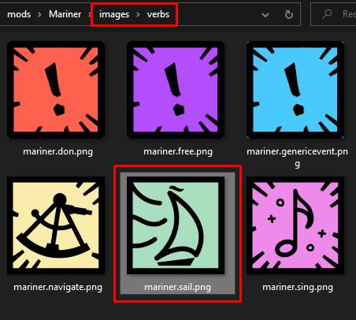

*A mod named "Mariner" would put its Verb icon for a new Verb named "mariner.sail" into images\verbs and name it "mariner.sail.png"*

* Aspect icons should be at most 128x128.
* Element icons should be at most 256x256.
* Ending cards should be 400x580.
* Legacy icons should be at most 128x128.
* Verb icons should be at most 256x256.

Avoid 1K, 2K, or 4K resolutions, as loading too many of these can make the game startup time way, way longer, or even crash the game (a handful of 2K pictures are enough to do that).

## What tools to use to make mods

The game's content being JSON text files, you should make use of a good text editor. There is no consensus inside the community, with people using everything from the base notepad to VSCode. **Just pick a tool you prefer and stick to it**. We're all just editing text files, after all.

It is still recommended to at least use Notepad++, as it provides syntax highlighting (fancy colours to read things more easily). A few reasons why you may want (but don't have to) pick more advanced softwares like VSCode:

* It can provide automatic formatting of the document
* It detects your format mistakes and displays them with red wavy underlines
* It can have the entire folder opened on the side to let you quickly jump from file to file
* It has powerful "search in everything" abilities
* It can tell you when you made a mistake like a badly written property name

If you have never touched that kind of software but wish to test one, VSCode is recommended. It is simple to install and handle, and has a [community-written extension](https://github.com/Tiinusen/vscode-cultsim) to handle spellcheck of the properties, provide autocompletion, and a visual UI if you're still a bit afraid of the idea of writing your mod all in text (you can find and install it in VSCode in the Extensions section in the side panel).

## General concepts

*Aspect, Elements, the difference, decks, Verbs, recipes, legacies, endings, burnimages (burns), …*

*All things have a property called "id", with a value unique to them. This is how things are referenced. TODO.*

## Sample mod: Chi Explores the City (and ascends by mistake)



This chapter will describe, step by step, from start to finish, a *relatively* simple mod that aims to show as many concepts and features as possible, while staying small enough that a beginner can understand it. Instead, if you prefer to just dive into the final result's files, a slightly improved version of this mod (mostly icons to make things fancier) is available on the [Steam Workshop, at this address](https://steamcommunity.com/sharedfiles/filedetails/?id=2820559817).

**Pitch**: The mod will add a new legacy, "Chi the Cat". Chi the Cat spends his time sleeping, asking for food, and exploring the City to collect little cat-treasures. The endgame is to collect enough of them for the Beachcomber to notice him, and decide to help him ascend as a Cat-Name. (This is, obviously, canon.)

Instead of Health or Reason, Chi will use his Attention (a new card) to do his actions.

What this sample mod will demonstrate:

* Legacies and how they work
* Cards
* Aspects
* Custom Verbs and editing existing Verbs
* How to spawn new Verbs (alt additional recipes)
* Actions (recipes), how to link recipes to make more complex actions, and how to use alt recipes
* Decks
* Endings

It cannot cover *everything*, but this should be enough to give you the confidence boost to start designing your own mod, and understand how things are structured and work.

|  | **Code Blocks**  All code block examples in this guide are pictures, but you can copy the code by right clicking on the picture > Alternative Text. |
| --- | --- |

### Step 0: Setting up the mod

In our local mods folder, we create a folder called ChiTheCat, with a synopsis file describing the mod itself, a cover picture (which can be a placeholder for now), a content folder, and an images folder. All the JSON files we will create will be in the contents folder.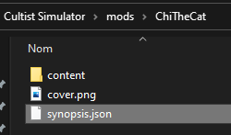

*The beginning of any new mod!*

The contents of the synopsis file:

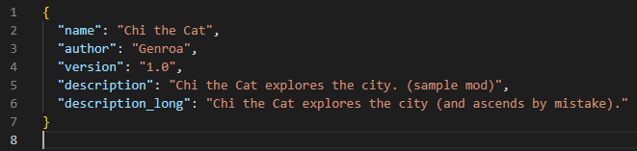

### Step 1: A new legacy

Chi the Cat will be its very own legacy! So let's start by writing one, in a dedicated legacy.json file.

Legacies have a few constraints they all have to follow: they start with one (exactly one) Verb on the board, and a few cards, preferably one to three at most. The starting state of the board is the beginning of the story: there is no need to make it a complicated mess right from the start. It’s for your own good. It *does* lead to an interesting question and design conundrum though: how do we provide more Verbs to the player? We will see that in the next step, but, for now, let's actually write the content of chi.legacy.json :

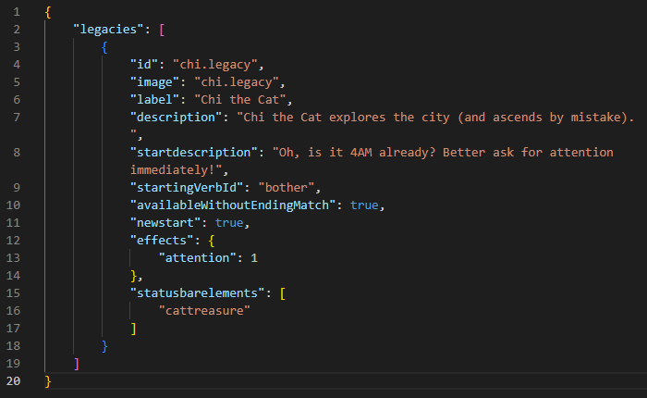

Let's immediately answer the most obvious questions about that bit, because legacy objects can have a lot of options to fill:

* "image" defines the icon for the legacy. It is mandatory for legacies, for some reason the game doesn't find it automatically based on the id.
* The description is the text being displayed when selecting the legacy in the menus.
* The startdescription is the popup being displayed when you start a new game of this legacy.
* We will use the "bother" Verb for our "attention-seeking" action, and so we will give that as the starting point. It doesn't exist yet, but we will define it in the next step.
* "availableWithoutEndingMatch" means the game can consider this legacy to be a valid new start after any end of any other legacy. (Some legacies are only available after a run that ends in a specific way.)
* "newstart" means we can manually select this legacy in the Sixth History menu to start it.
* "effects" is the property defining the list of cards to give at the start.
* "statusbarelements" is the property defining the elements whose quantities are tracked at the bottom of the screen. Chi only cares about his cat-treasures.

**Warning: for now, since some update the property requires exactly four things in it. Instead of what the screenshot says, define the property as follows: "statusbarelements": ["cattreasure", "cattreasure", "cattreasure", "cattreasure"]**

Starting the game with this, we can already see the mod:



If we enable it, we get:

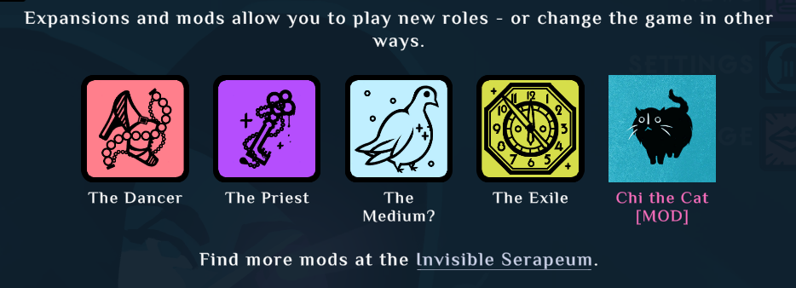

Good! Let's now actually create what we need for the start of the legacy.

### Step 2: The Start

Before even starting the legacy, we should, at the very least, define what "attention" is. So, let's start by creating a new file, elements.json, and write a new element in it. (Remember, files can only contain one type of object, so we cannot write legacies and elements in the same file!)

Here are the contents of the file:

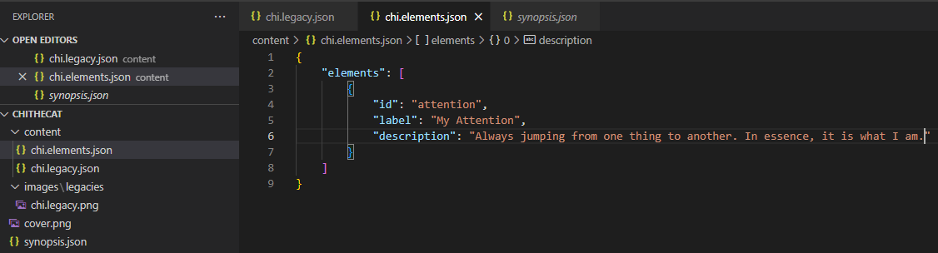

Fairly straightforward, it has a label and a description. Elements have many other properties that we can define for them, but most elements will at least define these.

We also need to define a "bother" Verb. Let's do that in a verbs.json file:

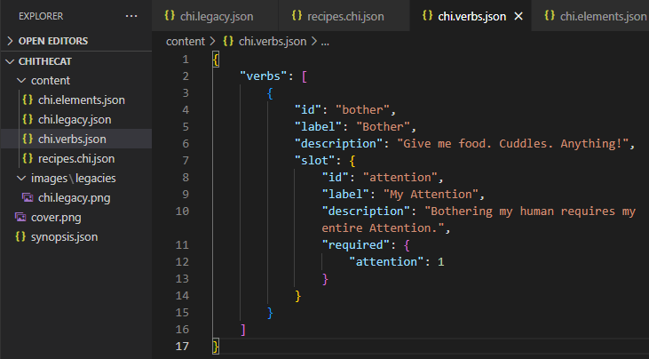

It has a label, a description (the text displayed by default when it is idle and empty), and a slot describing what cards it accepts.

Now, if we start the legacy, we get:

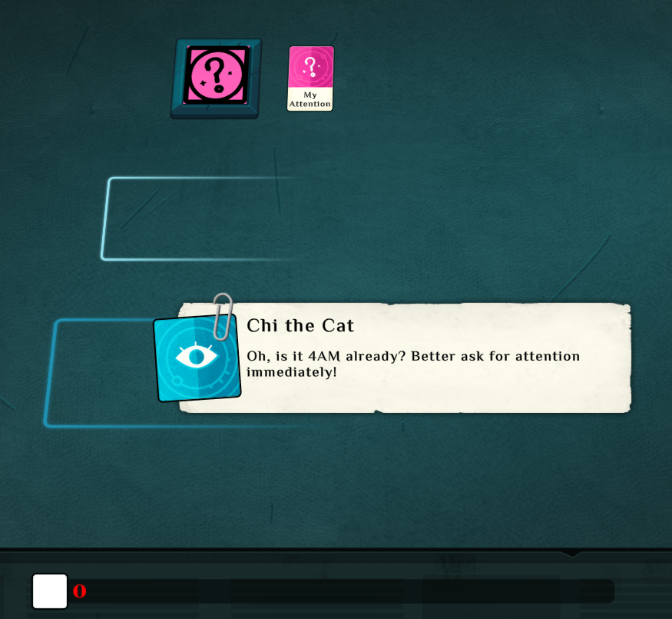

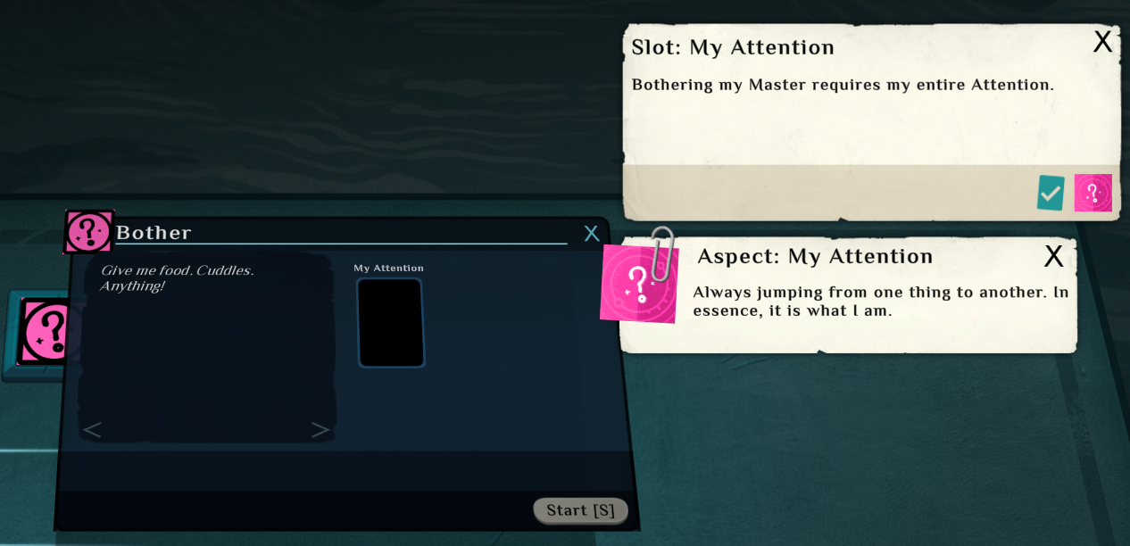

Notice that the status bar properly displays that we have zero cat-treasures, but doesn't display any icon. This is because we haven't defined what cat-treasures are yet (and even then, we haven't defined an icon for it). We will fix this later, but for now we have a bigger problem: there is nothing we can do with our attention. (We can put it in the slot, but nothing will happen.)

We will fix this in the next step. Let's see how to write simple actions (generally called recipes), by writing a simple "asking for food and cuddles" recipe that uses our fancy new "attention" card.

### Step 3: Simple action: asking for food and cuddles.

Recipes are the building blocks of the actions in the game. They are essentially:

* A set of requirements to meet (which cards, in which Verb, with what board state, etc.)
* A label and descriptions to display while the action warms up and when it completes
* A set of effects describing what happens when the recipe completes

When you put a card into a Verb's slot, the game will start to resolve every single recipe it knows, and select the first one that is “craftable” (can be manually started by the player) whose requirements are met, and display it. (If no craftable recipes have their requirements satisfied, the game may display a “hintonly” recipe instead.) The player can then Start it. Recipes are resolved in their order of definition: mod-by-mod, file-by-file, then top-to-bottom within each file.

Let's write a simple action (again, in a new recipes.json file) :

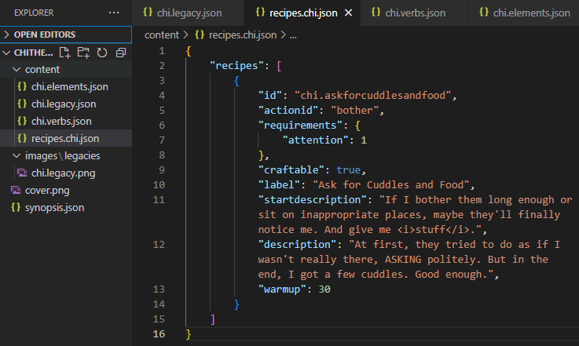

And the result:

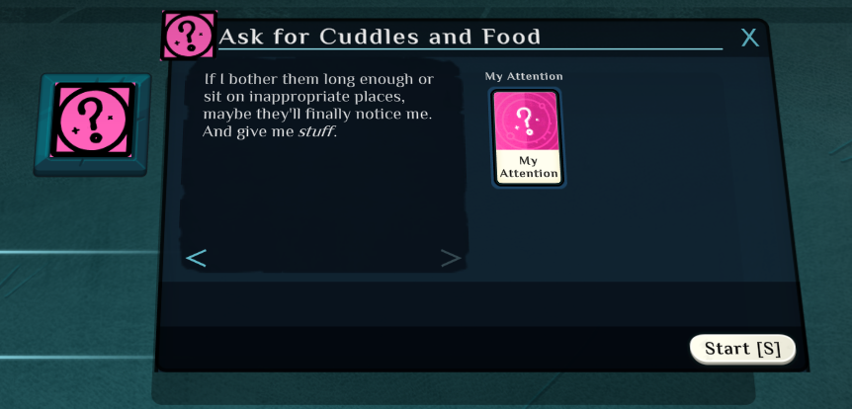

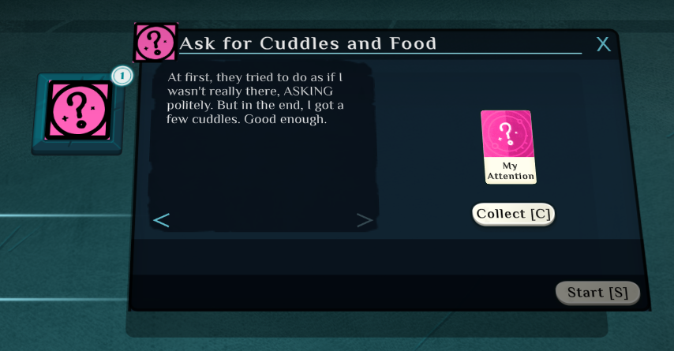

A few explanations about the properties on the recipe:

* "actionid" is the Verb's id for this recipe
* "requirements" is a dictionary listing what elements need to be present in the Verb, for it to be considered valid. Here, we require one "attention". (Keep in mind that “elements”, in this case, can refer to cards or aspects: this is how the game has an action startable with any "acquaintance", instead of writing one recipe for each of them.)
* "craftable" means the player can start it by hand (this is often forgotten and will be important in the next steps)
* "startdescription" is the text displayed before clicking Start, "description" is the text displayed when the recipe ends
* "warmup" is the amount of time (in seconds) before the recipe ends.

### Step 4: Getting the Explore Verb

Cool, we can now repeatedly ask for cuddles and food (although it doesn't do anything yet). But we still cannot explore. In fact, we don't even have an Explore Verb. Let's improve that by creating a simple "one time only" action that will serve two functions:

* It will let us display a few lines as the start of the story
* It will let us spawn a new Verb, "Explore".

We will add two new recipes to recipes.json. One will be the starting action of the entire legacy, where we decide to ask for attention at 4AM and, failing to get it, decide to go out and explore the city. The other recipe will actually be used to spawn the Explore Verb:

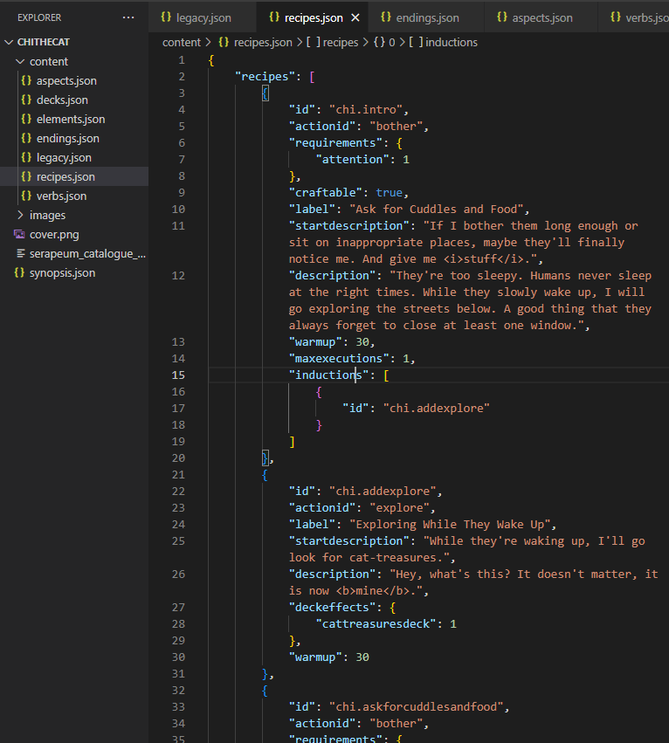

Alright, this will let us introduce a new concept, "induced recipes". We will explain what happens here step by step, starting with the simpler part: the "chi.explore" recipe.

It is a simple recipe, using the explore Verb, with one specific thing about it: there is no craftable property. The player won't be able to start it by themselves. (However, it can still be started by other recipes after they complete.) We only use it to introduce the explore Verb.

Now, the other recipe: "chi.intro". Most of it is similar to the "chi.askforcuddlesandfood" recipe, with two new things: maxexecutions, and alt.

The "maxexecutions" property is pretty self-explanatory: **this recipe can only run once**. Why do we do this? We defined it before the chi.askforcuddlesandfood recipe, so even if they have the same requirements, this one will be selected first! But…only the first time we start it. **This way, we can use it as a cool intro**, and, for any following action the player tries to start, the other recipe will be used instead.

The "inductions" property isn't much more complicated. It takes a list of recipe links, and if the verb they define as their actionId isn't already present and active on the table, it will spawn that verb and start the recipe in it. **This is how we spawn new Verbs**. The "chi.explore" recipe's only reason to exist is so that we can use it to make the Explore Verb spawn.

Starting the game, we now get:

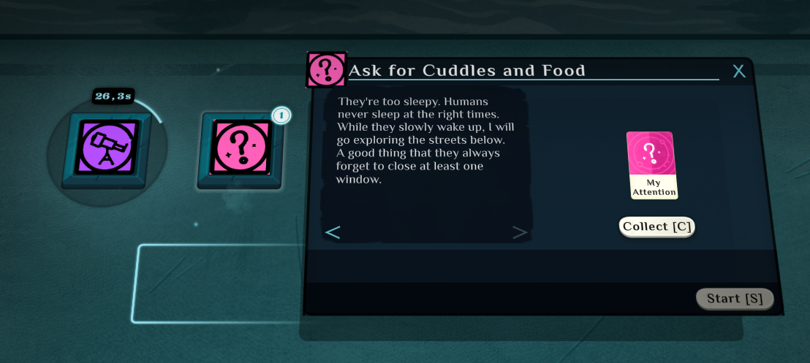

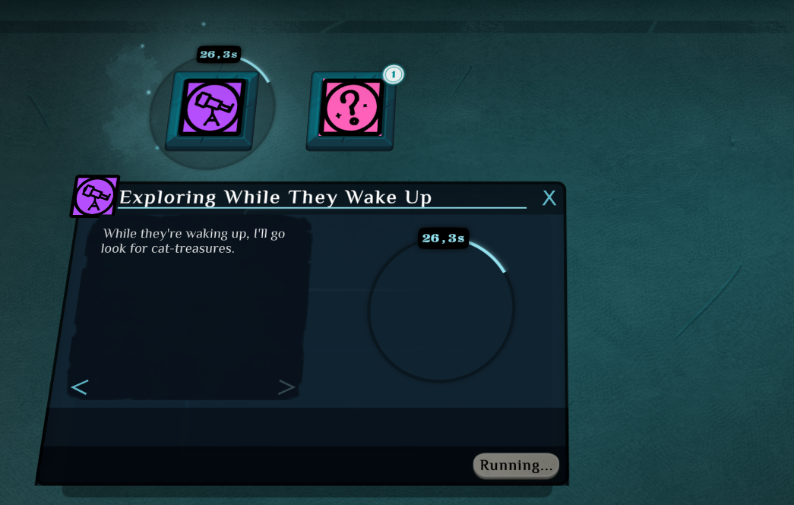

It doesn't give us any cat-treasure yet, and we cannot decide to search for cat-treasures ourselves. But we now have the Explore Verb! But it doesn't accept "attention" yet. Let's fix that.

### Step 4.5: Letting Chi explore with the Explore Verb

This step will be fairly short "code-wise", but the concept introduced here is important: **how to edit existing things**.

In our verbs file, let's add a new object after the definition of the Bother Verb:

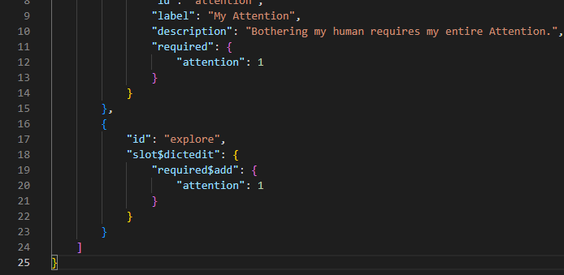

*"Wait, did we just redefine the existing Explore Verb?"*

Exactly. This is how "editing" works: you define something with the same id, but with different values. The new values will overwrite the previous ones (unless you use “property operations”), and the last thing to load gets priority. If you don’t want to overwrite everything, you don't have to define all the properties: only the ones you want to change.

*"Alright, but what are these $things?"*

Well, you see, we want to add "attention" to the authorised elements of Explore, not overwrite the set of authorised elements so only "attention" is authorised. We could do that, but then our mod would break the base game when enabled, and only this legacy would work. Playing with custom Verbs is easier because we cannot break anything, obviously.

We won't go into much detail, but what this text does is edit the slot "object" (or dictionary, or dict, or "something that is a set of key → value pairs"), and adds a new aspect to its "required" property. Adding "$something" to the end of a property allows you to do "property operations".

We basically wrote "do not overwrite the entire slot, we'll just edit a few things in it: we'll add aspects to the "required" property, nothing more".

We can now see that the explore Verb's slot accepts "attention" as a valid card. We just haven’t defined anything requiring it yet.

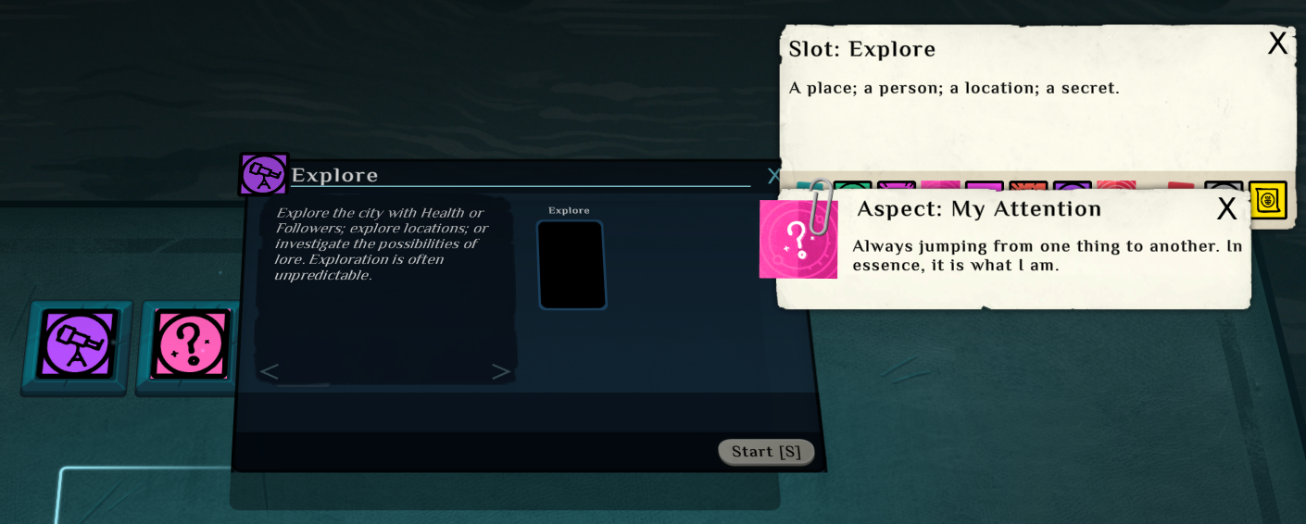

Good. Let's Explore, then.

### Step 5: A more complex action: looking for cat-treasures in the city

We will now define the exploration action, where we find exciting ~~junk~~ cat-treasures! The basic pitch for it is as follows:

1. We can start the exploration action with Explore+our attention card
2. There is a deck of cat-treasures to find
3. When the recipe completes, it draws a random cat-treasure from the deck.

For that, we will need to define a few new things:

* An aspect, "cat-treasure", that all cat-treasures will have (this is what the status bar will count!)
* Several new cards: the cat-treasures themselves
* A deck, containing the cat-treasures
* The recipe to draw things from the cat-treasures deck

Aspects are technically just elements, like the cards, but because they often fill a different role (metadata on the cards, instead of being cards themselves), convention says we should define them in a dedicated aspects.json file:

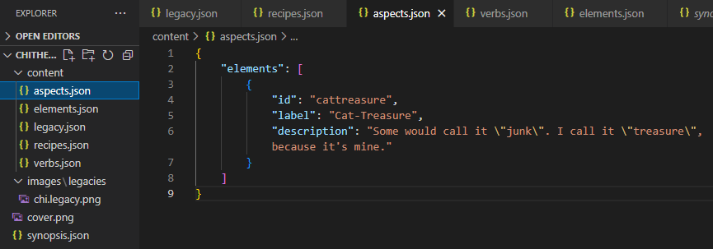

(Backslash, \, is used here to tell JSON that we want to use the doublequotes, not to terminate the string, but as an actual symbol to display)

Alright, let's define a few cat-treasures in our elements.json file:

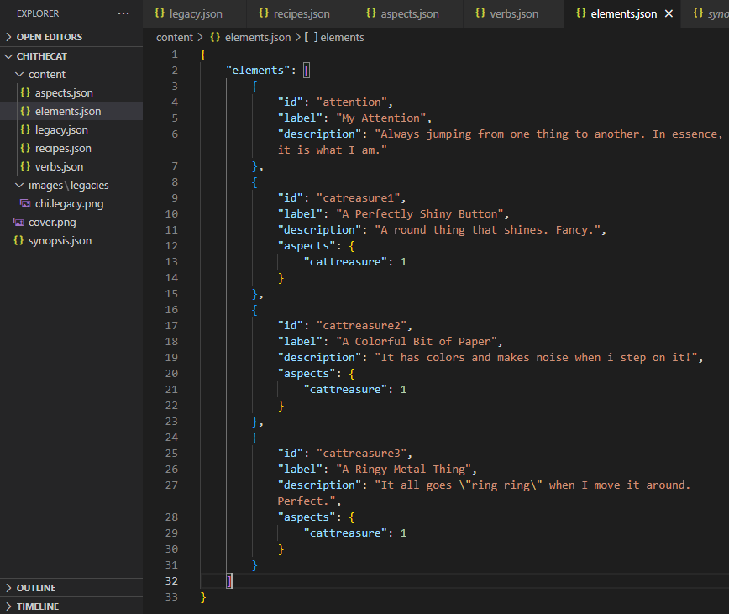

Notice how they all have the aspect "cattreasure".

Now, let's define the deck! (in a decks.json file)

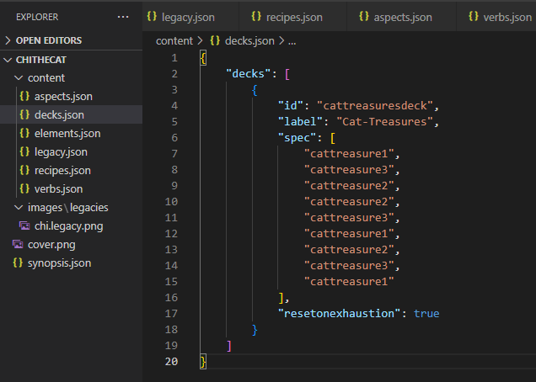

And finally, the exploration recipe in recipes.json:

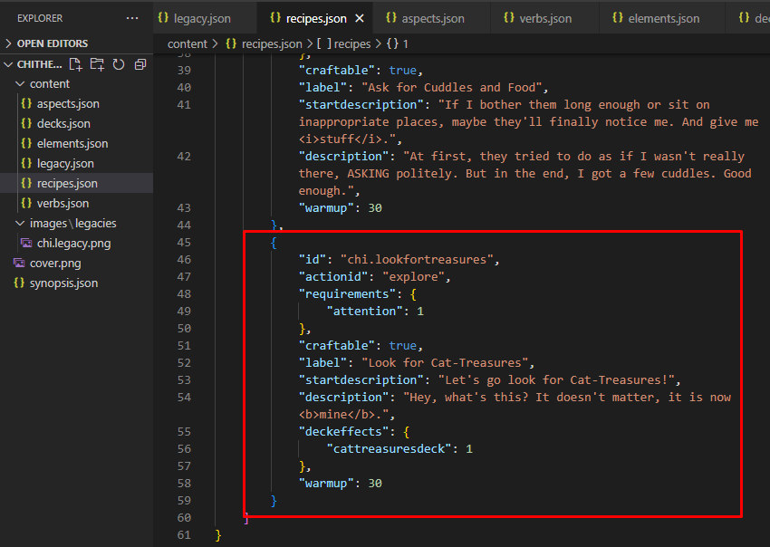

The only new property here is "deckeffects", that draws cards (or one card, here) from the specified deck(s). This recipe will draw one card from our deck, when it completes.

While we're at it, we will add "deckeffects" to the chi.addexplore recipe too.

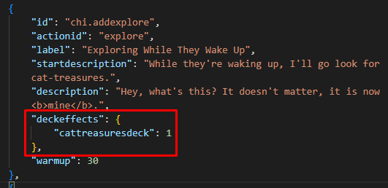

Cool, we can now collect a bunch of cat-treasures, and the status bar displays how many we got!

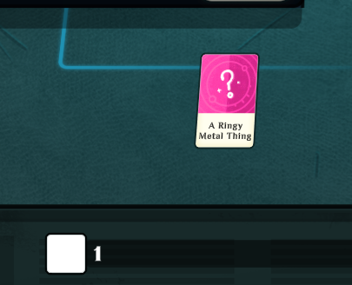

### Step 6: Chi ascends (somehow)

Alright, we are approaching the end of this tutorial. Let's give a way for Chi to ascend, by writing an ending for his adventures.

We'll write it in a dedicated endings.json file:

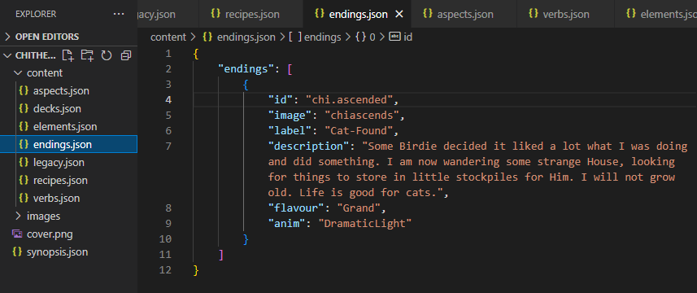

Endings have a few properties to customize the ending picture, the kind of music and warmup style you want. But that's pretty much it.

We now have an ending, but we cannot reach/trigger it yet. Let's fix that, and then our mod will be complete!

We do not want the end to be triggered each time we explore. Suppose we want it to happen after collecting 10 cat-treasures. Recipes can have a property called "ending": with this, they will trigger the defined ending when they complete. Because we do not want our exploration action to trigger our ending directly, we will do it in a different recipe and **link to it**.

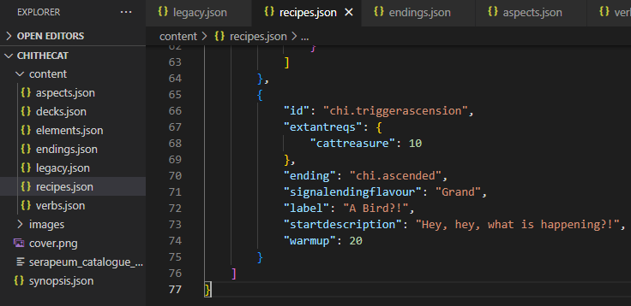

The recipe itself is pretty simple, with one new addition: "extantreqs". It's just like "requirements", but instead of looking at what is inside the Verb, it will check the entire game (table and what's inside all the Verbs). So even if we were to do something with our cat-treasures in the Bother Verb (like offering them to our human), this condition would still count them.

Now, we want to start this recipe right after the collection action completes, but only once we’ve collected enough cat-treasures. To do this, we:

* Link it at the end of the collection action
* Put requirements in the ending recipe

How does it work? When a recipe completes, two things can happen:

* If it doesn't have any linked recipe, or no linked recipe's requirements are valid, it will end and display its "description" text.
* If it has linked recipes **and at least one has valid requirements**, it will pick the first valid recipe in the list and start it immediately.

This way, the collection recipe will only start our ending recipe when it completes if we have found 10 cat-treasures. Otherwise, it will simply display its end description and stop there. Let's add the link itself:

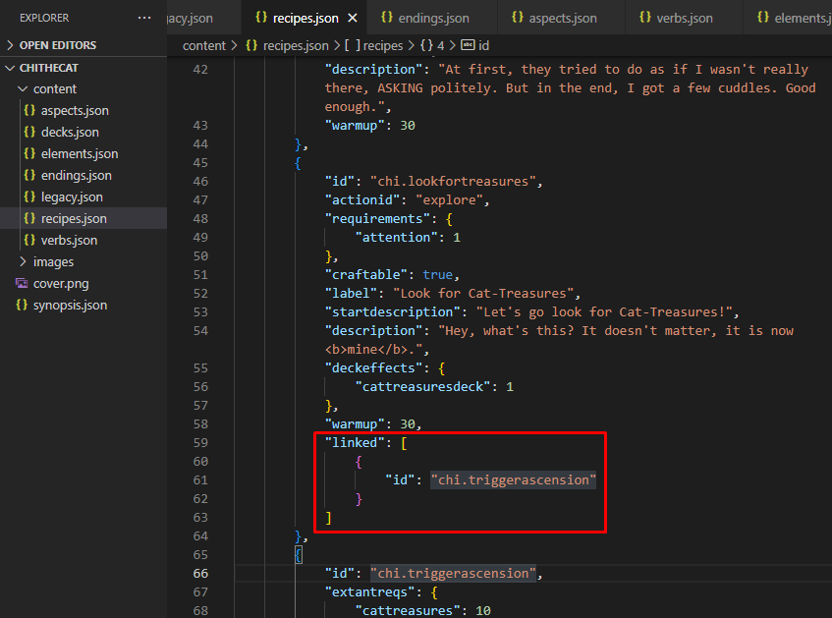

**And that's it!**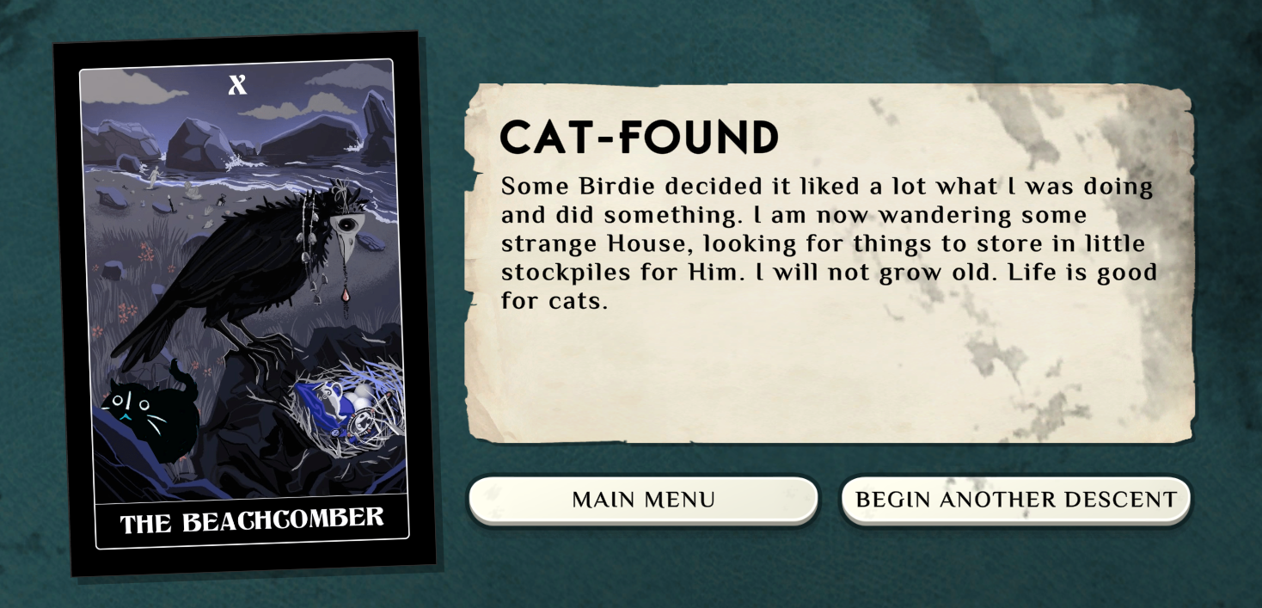

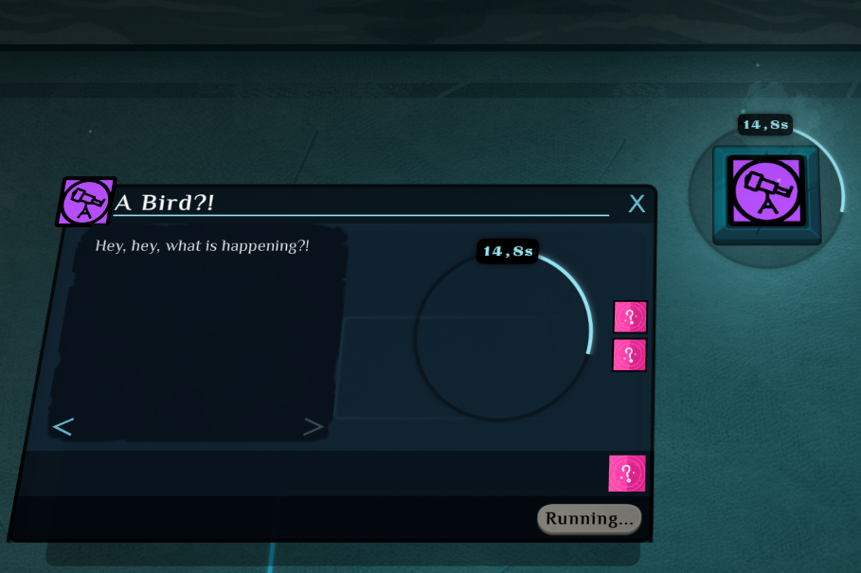

This is the end of this tutorial. A slightly improved version of this mod (mostly icons to make things fancier) is available on the [Steam Workshop, at this address](https://steamcommunity.com/sharedfiles/filedetails/?id=2820559817). If you need another way to get it, come to the #modding channel of the [Weather Factory Fan Discord Server](https://discord.gg/ub2tE6Y).

### Bonus Step 7: Alternative recipes: give food to ask for the help of the other cats of the city

(todo)

## 

# 

# Building Blocks of Cultist Simulator

## Content Format

The content of Cultist Simulator is written in JSON files. JSON files are text files following the JSON standard.

|  | Each file can only contain one type of content (element, recipe, deck, verb, ...). Violating this restriction will trigger a crash on startup, or lead to parts of the file being ignored entirely. |
| --- | --- |

Each files follows the exact same structure:

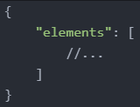

For each content file, there is a top level object containing one or more lists/arrays of objects. Only one list/array of one type can be included per file; but you can add as many files as you like. These lists/arrays are named one of the following: "elements", "recipes", "decks", "legacies", "endings", or "verbs".

## Modifying Base-Game Resources

#### 

#### +Merge-Overwriting

If you create a recipe, element, legacy, ect. and set the ID to the same as a base-game (or another mod’s) recipe, element, legacy, ect. they will merge-overwrite. This is a behaviour where you can apply changes to the base-game resource without having to redefine everything about it, allowing other mods to change the remaining parts.

|  | **Internal decks have deck IDs**  Internal decks have externally-defined deck IDs. These IDs are defined as “deck.” followed by the recipe ID.  E.G. to modify the internal deck belonging to the recipe “explore.fleeting”, you simply use the deck ID “deck.explore.fleeting”. |
| --- | --- |

When merge-overwriting, only the defined properties will be overwritten: everything else about the original game object will remain the same. Example:

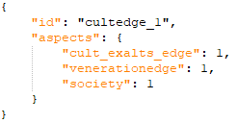

This code will cause the Church of the Bright Edge (“cultedge_1”) to have one of each of the aspects “cult_exalts_edge”, “venerationedge”, and “society”, instead of any other aspects the card might have (except for those added by other mods, through property operations; more on that later). This will ***not*** make any change to the card’s label, icon, description, uniqueness, or slots.

#### Overwriting

Aside from the “big six”, objects in Cultist Simulator *can’t* be merge-overwritten, and can only be overwritten. This is as simple as redefining the same object using the same ID.

* For images, if an image with the same name is put in a mod folder, it will automatically be used instead of the base-game asset with the same name.
* Properties of the six/seven main object types cannot be merge-overwritten. This means that slots, numbers, strings, booleans, and other properties cannot be modified without being overwritten... though certain allowances are made through property operations.
* Localization files use this same principle when overwriting text from the base game. Due to an oversight in the Fucine modloader, only the last-loaded localization change will apply to a given string. In general, this means that non-Chinese localization can only work if no Chinese localization is installed, regardless of the game’s (non-English) language setting.

## Property Operations

When merge-overwriting, it is possible to adjust some properties without replacing them: namely lists and dictionaries. These adjustments are made through property operations. Using a property operation is done by adding a $ and the operation name to the name of the property to be modified.

Each entry that you would want to modify must have its id specified for the game to know to which entity the changes are supposed to be applied, like so:



#### Dictionaries

A good part of the game's effects are achieved with dictionaries: “aspects” for both aspects on elements, recipes and even potentially verbs themselves; “requirements”; “effects”; “mutations”; among others. Dictionaries are usually enclosed with {} brackets.

* To add new entries to dictionaries you can use $add, followed by the additions you want to make in the form of a dictionary:

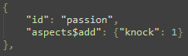

It's also important to note that $add on dictionaries where a specific entry exists, like passion having 2 moth, would override that entry’s number, not add to it.

* To remove entries from a dictionary you can use $remove, followed by entries you want to remove in a list:

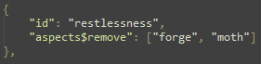

* If you want to edit specific parts of a dictionary without overriding the rest of it you should use $dictedit in addition to any other operations you want to conduct on that part of the dictionary:

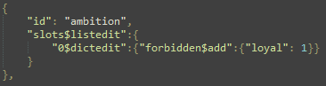

This example uses $listedit, which is $dictedit’s counterpart for lists and will be explained later

#### Lists

Lists are ordered and support different operations than dictionaries. Examples of lists are element and recipe “slots”; recipe links, be they “linked”, “alt”, “inductions” or even element “induces”; and “decks”; among others. Lists are usually enclosed with [] brackets.

* There are 2 properties that allow you to add entries to lists: $prepend to add them at the beginning of the list and $append to do so at the end. In both cases the entries are added in the order they are written.

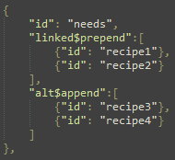

* In rare cases where the list is a list of strings, as with “decks”, $remove can remove them from the deck.



* If for some reason you need to remove a more complex entry in a list, you must target it specifically with $listedit, which is defined as a dictionary and not a list. It also targets specific entries by index (with the 1st entry being the one with index of 0), and usually with a $dictedit:



$listedit can be also used to insert an entry at a specific index of the list:

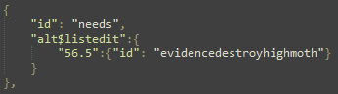

This specific change would insert the link to the listed recipe between 56th and 57th index, right before “evidencedestroymidmoth” recipe link.

Removing a more complex entry from a list is a more complex problem. There are 2 main ways:

* One way would be to add specific “requirements” which prevent the recipe from being valid as a follow up; however, not all lists are recipe links and so this is not a universal solution.
* Another way would be to explicitly remove it from a list with $dictedit on a specific index:

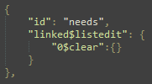

NOTE This specific edit targets the entry at 0 index in the list named “linked”, removing the link to the discardseason recipe, effectively making the time verb stop after the “needs” recipe finishes. This change is to illustrate the mechanic, and the specific change to “needs” is not recommended in any mod that is supposed to be playable with a time verb.

It's also not ideal to use in most common lists since it requires you to know the index of the specific entry, which can change if other mods are used.

#### Values

Some properties have explicit values, like “warmup”; “lifetime”; or the contents of some dictionaries, like “aspects”. There are 2 properties that allow you to modify them: $plus, which adds the provided number to the base property, and $minus, which subtracts it from the base property.

#### Strings

Some properties contain strings directly, like “label”; “description”; or even “id” among others. Properties $prefix and $postfix take a string as input and allow for inserting the provided string at the start or the end of the base property, respectively. $replace takes in a list of “string1”:”string2” pairs inside dictionaries and replaces any instance of “string1” with “string2”. $replacelast does the same, but with only the last instance of each “string1”.

#### Property agnostic operations

There are some operations that can be applied to any property, but there are not many of them.

* $clear followed by either “” or {} clears the contents and the property entry of the operated property.

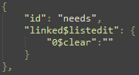

#### Entity level property operations

There are a few properties that are applied to the whole entity, be it element, recipe or something else. This applies mostly to the things contained within the {} brackets of that entity.

* $extends takes in another entity id, copies it to the entity that the property is invoked in, and then takes any changes and overrides them onto the base copied properties.

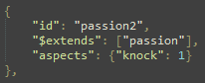

In this case, the product would be an element in most ways identical to passion card (without its art, which is not invoked via property but by the name of the image being the same as the element) but with its only aspect being 1 knock.

* $derives works mostly the same as $extends but any listed properties in that entity will be merged with the ones imported by $derives.

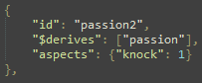

This nearly identical entry would result in an element with all of the defined properties of passion, but with the addition of 1 knock.

* $priority can alter the load order of the specified entities. 0 is default, with higher numbers loading earlier and lower (negative) numbers loading later; whatever loads later overwrites values loaded earlier. This is useful in many cases, with one of most obvious benefits being for recipes - recipes loaded earlier are displayed before those loaded later, which is very useful if you want your recipe requirements to overlap with some other recipes, which will in most cases be base game ones.

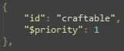

Usually adding or removing 1 to priority is enough, as the order of craftables can be also impacted by file path names inside a mod as well as the order of the definitions inside the files themselves.

* $contentgroup is a list of strings that marks entities with those strings as tags. It's mostly useful for making mods with their own options, as it’s one part of a mechanism which allows for mods with multiple options.

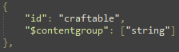

* $depends is a list of strings. If a mod with a matching serapeum catalogue number or name in its synopsis file is enabled, the content of this entire entity is loaded, otherwise it is not. The list is an AND list, so *all* of the listed mods need to be enabled for the entity entry to be loaded. This property allows for cross-mod optional compatibility.
* $incompatible is a list of strings. The complement to $depends, it’s a list of serapeum catalogue numbers or internal mod names that, if enabled, prevent that entity from loading; otherwise, the content of the entity loads normally. The list is an OR list, so if *any* mod on the list is enabled then the entire entity entry will *not* be loaded.

Regarding both $depends and $incompatible - mods internal name is only checked if the mod does NOT have a “serapeum_catalogue_number.txt” file.

## Full Reference

The following sections of the documentation will list, and provide examples, for every single property of each type of object in the game.

## 🐓 About the Bird

The end of some sections have additional "bird" 🐓 properties. In addition, some property references possess a "bird block". It is because it lists the properties and additional feature details that are only available if you use The Roost Machine, a DLL-mod written to add new features to the modding framework. Using them means both you and your players **will have to subscribe to The Roost Machine in order to enable and play your mod**. It contains convenience properties, but also many more advanced properties which you may not need. Keep this in mind if you decide to use these properties. The choice is up to you.

Some properties have additional features or more flexibility provided by The Roost Machine. These will be displayed in a block like the one you can see below. On top of that, to see at a glance which feature is exclusive to The Roost Machine and not present in the base game at all, note that their name will be prefixed by 🐓 icon, and they will always be at the end of the properties list.

|  | **Roost's specific informations**  Generally speaking, any information block marked by the bird icon means this information/feature is specific to The Roost Machine, and is provided here in a single document for convenience. |
| --- | --- |

## 

## 📖 About the Book

The end of some sections have additional "book" 📖 properties. These properties are specific to the Codex mod, a DLL-mod adding a logbook/encyclopaedia feature to the game. **Players will have to subscribe to and enable Codex in order to benefit from these**. If they don't, the codex actions will be ignored. In most cases, it means players can ignore this feature, but if your logic relies on checking for the existence of codex entries to influence the gameplay, then it obviously becomes mandatory.

The Codex mod lets you define elements ("cards") to use as unlockable codex entries that can be dynamically changed via the use of refinement blocks and aspects mutated onto them. This is what the updateCodexEntries property does. **It relies on the Roost Machine and it is a mandatory dependency for it.**

## Elements

### Description

*Elements are the nouns of the sentence. They are things that are.*

Elements encompass two categories; cards and aspects. Cards are the nouns, the things you use in the game. They are, among other things, defined by a set of aspects. The aspects are special elements with fewer properties, that can be seen as metadata, or a more granular type of information we can act on.

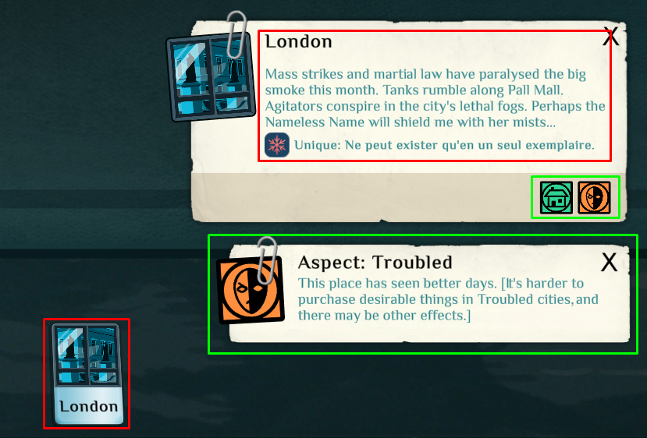

Red = Card. Green = Aspects of the “London” card.

The cards on the table are elements. The aspects of cards are also elements. Everything that’s represented as a card, from Lore, Books, Patrons, Influences, is an element.

### Properties of all Elements

"Elements" describe what you could commonly refer to as "the cards", but also "the aspects". Some properties are specific to cards, some to aspects, and some are common. This section lists the common properties, and the following ones list the things specific to each.

#### Element ID

| Property name | id |
| --- | --- |
| Explanation | The unique identifier of the element. This is used to refer to the element.  If the id is not unique, it will merge-overwrite with all other elements that share the same id.   |  | **Spelling Causes a Crash on Startup**  Spelling mistakes made when referencing this ID can create issues in your mod, such as XTriggers failing to operate, incorrect recipes being executed, or the game crashing (though not necessarily at startup.) The player log is likely to include a line that says something akin to “unknown element id specified: scholardeepmandaic”. This will indicate what element ID *doesn’t* exist, but will not indicate what the correct spelling is. (In this case, “scholarmandaic”.) | | --- | --- | |
| Default value | No default value. **This property is mandatory.** |
| **Examples** | |
| Simple use of the property | {  "id": "myid"  } |

#### Label

| Property name | label |
| --- | --- |
| Explanation | The name displayed on the card. For aspects, the label is displayed as the title of the description when its icon is clicked on, and it is prefixed with “Aspect: ”.   |  | Labels can contain refinement blocks. They cannot be nested, but you can use multiple in the same label.  *What is this Bird?* | | --- | --- | |
| Default value | "" (empty string). |
| **Examples** | |
| Simple use of the property | {  "id": "myid",  "label": "Some label"  } |

#### 

#### Description

| Property name | description |
| --- | --- |
| Explanation | The text displayed in the top-right corner when the aspect/card is clicked on.   |  | Descriptions can contain refinement blocks. They cannot be nested, but you can use multiple in the same description.  *What is this Bird?* | | --- | --- | |
| Default value | "" (empty string). |
| **Examples** | |
| Simple use of the property | {  "id": "myid",  "description": "Some description"  } |

#### 

#### Is It an Aspect?

| Property name | isAspect |
| --- | --- |
| Explanation | For cards (“full elements”, “non aspects”), this should always be false, or more simply, not defined at all.  For aspects, this should be true. This is used by many modding tools to differentiate aspects from other elements (as the two can have very different properties), but the game only considers this value when determining where to look for the element’s art. (If the element is on a card as an aspect, the game will check “images\aspects” only if this value is set to true. If the element is a card, or if it does not have this value as true, the game will check “images\elements” instead.) |
| Default value | false |
| **Examples** | |
| Simple use of the property | {    "id": "acquaintance",    "label": "Acquaintance",    "description": "Not yet a friend, nor yet an enemy.",    "isAspect": true   } |

#### 

#### 

#### Icon ("icon")

The name of the file for the icon of this element. Cards get their art from images/elements. Aspects get their art from images/aspects (see the isAspect property for their distinction). This value defaults to the ID of the element, and can be removed if the desired image has a filename matching the ID of the element, and is in the appropriate folder.

### 

|  | **When Not to use Special Characters**  If the element id uses non-letter characters (“something.otherthing.anotherthing” or "something_otherthing"), and the icon has the same name, then it cannot be used as a status bar element. The status bar icons cannot have special characters in them, and because the name of the icon has to have the same name as the value of the “icon” field, you cannot use special characters in the value of this field if you plan on displaying this element into the status bar. |
| --- | --- |

### 

#### Induces ("induces")

Whenever this element is present and face-up (ie: not from effects or deckeffects) at the conclusion of a recipe chain, the induced recipe may be created as a new verb depending on the designated chance. This will not occur if an active verb with the same actionIdis already on the table, but it *will* ignore any requirements, extantreqs, or tablereqs associated with the induced recipe.

Examples of inductions include the Heart aspect starting 'Course of the Heart', or the Ingredient aspect starting 'needs'.

#### Decay Element ("decayTo")

**Specific to non-aspect elements (sort of).** The element that this element will turn into when its lifetime reaches 0. Mutated aspects are unchanged by decay. (As an advanced feature, this can be applied to aspects to achieve a specific behaviour when used with Purge, but has no effect on its own because aspects cannot decay.)

Examples of decay elements being used include Restlessness decaying to Dread, or Health [Fatigued] decaying into Health.

#### Verb Icon ("verbicon")

When this element is present in a Verb, that Verb’s icon will become the icon indicated. Note that the icon must exist in “images\verbs”. It is currently unknown what happens when the image does not exist or more than one Verb Icon is defined.

#### XTriggers

| Property name | xtriggers |
| --- | --- |
| **Explanation** | |
| What xtriggers are Xtriggers (or "cross triggers") are effects defined on elements, executed when a recipe they're in completes, and a specific aspect (sometimes called the catalyst) is present in the same scope (usually, the same verb).  For instance, this is how the health card turns into the "Health [fatigued]" card when used in the Work verb: it reacts to the presence of the "job" aspect on any card present with it. This is done via a xtrigger transforming itself into the fatigued version of itself. That way, we don't have to replace the card by another in every single action that might use a job card. If it finds one, the Health card will transform by itself in the presence of any job card. **Xtriggers are powerful, but use them with caution: they can lead to unintended side effects.**  A common pattern is also to define xtriggers on elements, and then execute them via the aspects property of recipes: this makes elements think these aspects are present inside the verb when the recipe completes, without actually having an element possessing them. You can see these as a way to "signal" to an element that it needs to do something. It is a form of controlled reaction. Syntax The syntax of this property is as follows:   | {  "xtriggers": {  "catalystaspect": [  // first xtrigger effect  {"morpheffect": "transform", "id": "newcard"},  //... (other xtrigger effects for this catalyst)  ],  //... (other catalyst-trigger definitions)  }  } | | --- |   Xtrigger effects have a few properties. Some are ignored, based on the morph effect:   * morpheffect: the type of the effect. See full list below. Mandatory. * id: the id of the thing to spawn/transform into/mutate onto the element. * level: the amount to spawn/mutate onto the element. Default value is 1. **When using the Roost, can be defined as an expression.** * chance: the probability (0-100 integer) that the xtrigger effect actually fires. Default value is 100. **When using the Roost, can be defined as an expression.**   When you only wish to define:   * one effect in reaction to a catalyst (as it is almost always the case), * and this effect is to just transform the element into another (which is the most frequent effect used),   then you can use this simplified syntax:   | {  "xtriggers": {  "catalystaspect": "newcard",  //... (other catalyst-trigger definitions)  }  } | | --- |   Xtrigger effect types Below is the list of xtrigger effects (called "morph effects") supported. **The ones in blue are Roost-only.**   | transform | Transforms the current element into another. **All the mutations previously applied to the element are kept though.** If the level property is defined to something more than 1, it will duplicate the current element and its mutations into several instances of the new element.  If level is set to 0, the element is destroyed.   | **Examples** | | --- | | {  "id": "mycard",  "xtriggers": {  // turn mycard into a newcard when the catalystaspect aspect is present  "catalystaspect": "newcard"  }  } | | {  "id": "mycard",  "xtriggers": {  // turn mycard into a newcard when the catalystaspect aspect is present  "catalystaspect": {"morpheffect": "transform", "id": "newcard"}  }  } | | {  "id": "mycard",  "xtriggers": {  // turn mycard into three instances of newcard when the catalystaspect aspect is present  "catalystaspect": {  "morpheffect": "transform",  "id": "newcard",  "level": 3  }  }  } | | | --- | --- | --- | --- | --- | --- | | spawn | Creates a new element in the verb. The amount created is set by the level property.   | **Examples** | | --- | | { "id": "mycard",  "xtriggers": {  "catalystaspect": {  "morpheffect": "spawn",  "id": "newcard",  "level": 2  }  }  } | | | quantity | Adds or removes some amount of this element to/from the verb. The quantity is defined by the level property.   | **Examples** | | --- | | {  "id": "mycard",  "xtriggers": {  "catalystaspect": {  "morpheffect": "quantity",  "id": "newcard",  "level": 2  }  }  } | | | mutate | Mutates an aspect on the element additively. The quantity is defined by the level property.   | **Examples** | | --- | | {  "id": "mycard",  "xtriggers": {  "catalystaspect": {  "morpheffect": "mutate",  "id": "newaspect",  "level": 2  }  }  } | | | setmutation | Mutates an aspect on the element non-additively. The quantity is defined by the level property.   | **Examples** | | --- | | {  "id": "mycard",  "xtriggers": {  "catalystaspect": {  "morpheffect": "setmutation",  "id": "newaspect",  "level": 2  }  }  } | | | deckdraw | Draws cards from the deck specified by the defined id. The amount of cards drawn is defined by the level property.   | **Examples** | | --- | | {  "id": "mycard",  "xtriggers": {  "catalystaspect": {  "morpheffect": "deckdraw",  "id": "mydeck",  "level": 5  }  }  } | | | deckshuffle | Shuffles the deck specified by the defined id.   | **Examples** | | --- | | {  "id": "mycard",  "xtriggers": {  "catalystaspect": {  "morpheffect": "deckshuffle",  "id": "mydeck"  }  }  } | | | destroy | Destroy the reacting card. To destroy another card, use the grandEffects morpheffect.   | **Examples** | | --- | | {  "id": "mycard",  "xtriggers": {  "catalystaspect": {  "morpheffect": "destroy"  }  }  } | | | decay | Decay the reacting card. To decay something else, use the grandEffects morpheffect.   | **Examples** | | --- | | {  "id": "mycard",  "xtriggers": {  "catalystaspect": {  "morpheffect": "decay"  }  }  } | | | leverfuture | Sets the value of the future lever specified by the given id to be the id of this element.   | **Examples** | | --- | | {  "id": "mycard",  "xtriggers": {  "catalystaspect": {  "morpheffect": "leverfuture",  "id": "somelever"  }  }  } | | | leverpast | Sets the value of the lever specified by the given id to be the id of this element.   | **Examples** | | --- | | {  "id": "mycard",  "xtriggers": {  "catalystaspect": {  "morpheffect": "leverpast",  "id": "somelever"  }  }  } | | | timespend | Adds or removes some amount to the lifetime of the element. The amount is defined by the level property, in milliseconds. By default, the effect removes milliseconds from the lifetime. **Define a negative level value to add to the lifetime.**   | **Examples** | | --- | | {  "id": "mycard",  "xtriggers": {  "catalystaspect": {  "morpheffect": "timespend",  "level": 20  }  }  } | | | timeset | Sets the lifetime of this element to exactly the given amount, defined by the level property, in milliseconds.   | **Examples** | | --- | | {  "id": "mycard",  "xtriggers": {  "catalystaspect": {  "morpheffect": "timeset",  "level": 20  }  }  } | | | grandeffects | Execute a specified set of recipe effects.   | **Examples** | | --- | | {  "id": "mycard",  "xtriggers": {  "catalystaspect": {  "morpheffect": "grandeffects",  "grandeffects": {  "effects": {  "notoriety": 2  },  "movements": {  "~/tabletop": "hunter"  }  }  }  }  } | | | induce | Spawn a verb running the recipe defined by the specified id. This morph effect also supports the expulsion property to expulse things into the new verb, but not the challenge property.   | **Examples** | | --- | | {  "id": "mycard",  "xtriggers": {  "catalystaspect": {  "morpheffect": "induce",  "id": "myrecipe"  }  }  } | | | link | Prepends the given recipe as a link for the linked property of the recipe, right before it resolves which link to route to next. This is not a permanent addition, it is only for this current recipe execution.   | **Examples** | | --- | | {  "id": "mycard",  "xtriggers": {  "catalystaspect": {  "morpheffect": "link",  "id": "myrecipe"  }  }  } | |  Subtleties of the system: how quantities act and other gotchas This section is dedicated to clarify all the possible edge cases and general important things to know about the way xtriggers work. How quantities affect the reaction In vanilla, the catalyst quantity (the amount of the element making the xtriggers react) is never taken into account. Having 1, 2, 5 job cards doesn't change anything. The reacting quantity (how many elements having this xtrigger are present in the verb) is never taken into account either, with one exception: the **transform xtrigger**.  This means that if you have 3 instances of the element, with a spawn xtrigger of level 2, when xtriggers are resolved, only 2 cards will be spawned, not 6. But if you have 3 instances of the element, with a transform xtrigger set to level 2, you will get 6 new cards replacing the 3 previous ones (3x2).   |  | **The Roost and the additional features**  The Roost defines two additional boolean properties on morph effects: useMyQuantity and useCatalystQuantity. Their default value is false.  When useMyQuantity is true, the reacting quantity is taken into account. If you have **3** elements with a spawning xtrigger set to level **2**, reacting to the job aspect, when the job aspect is present in the verb, **it will spawn 3x2 = 6 new cards, not just 2**. Note that reacting quantity isn’t always the same as the card’s quantity - in cases when it's an aspect that reacts to an xtrigger, “my quantity” is a quantity of that aspect, not of the card that has it.  useCatalystQuantity works the same way for the catalyst aspect. If you have **3** elements with a spawning xtrigger set to level **2**, reacting to the job aspect, when a recipe completes with **4** of the job aspect in it, **it will spawn 4x3 = 12 new cards.**  Both can be enabled. If both are enabled, and you have **3** elements with a spawning xtrigger set to level **2**, reacting to the job aspect, when a recipe completes with **4** of the job aspect in it, **it will spawn 4x3x2 = 24 new cards.**   | **Examples** | | --- | | {  "id": "mycard",  "xtriggers": {  "catalystaspect": {  "morpheffect": "spawn",  "id": "newcard",  "level": 2,  "useMyQuantity": true  }  }  } |   *What is this Bird?* | | --- | --- | --- | --- |  Xtriggers defined on aspects When xtriggers are defined on an aspect, and this aspect is assigned to an element, its xtriggers are evaluated too. But they're evaluated as if the xtrigger was defined on the element and not the aspect. Basically, the xtriggers evaluated on an element are the sum of its own xtriggers, and the ones defined on its aspects. Order of evaluation Spawned/mutated/transformed elements aren't taken into account during the evaluation of the current xtriggers. This means a card created via a spawn xtrigger won't immediately react during the same evaluation pass.  There's one subtlety to that though: **xtriggers are evaluated twice**. First, the recipe's aspects property is used to evaluate any potential xtrigger reaction based only on that, then a second pass is done to evaluate the xtriggers based exclusively on the actual content of the verb.  It shouldn't lead to any issues, but in case you rely on complex xtriggers and weird things start to happen, this could explain your puzzling bugs. | |
| Default value | {} (no xtrigger) |

#### Achievements

| Property name | achievements |
| --- | --- |
| Explanation | This property defines the list of achievements to unlock when this element, or an element possessing this element in its aspects, is interacted with for the first time (collected, usually). |
| Default value | [] (no achievement unlocked) |
| **Examples** | |
| Simple use of the property |  |

### Properties specific to Aspects

#### Hidden (“isHidden”)

This causes the aspect not to appear on any in-game aspect lists.

An example of a hidden aspect is ‘legacyplotitem’, which does not appear on the aspect list of A Bequest, nor does it appear on the required/allowed aspect list of the Study Verb, despite it being in both lists.

#### No Art Needed ("noArtNeeded")

This keeps the game from searching for artwork for this element, and defaults to false. This supposedly offers a small improvement to performance. In general, this should only be true if "isHidden" is true, or if this is an aspect that will only be used as a recipe aspect and XTrigger catalyst. More on XTriggers later.

### Properties specific to Cards

#### Aspects ("aspects")

**Specific to non-aspect elements.** A dictionary of aspects contained by the element, where the aspect id is associated to the amount of this aspect. These act as metadata.

### 

|  | **Elements as aspects**  Very rarely, full card elements can be included in the aspects dictionary, but then that element's sub-aspects are ignored. E.G. adding ‘fragmentknockc’ to a card’s aspect list will not give the card ‘knock’, ‘lore’, or research challenges. |
| --- | --- |

#### Lifetime ("lifetime")

**Specific to non-aspect elements.** The card duration. When it reaches 0, it will either transform into the Decay Element, or if there isn't one, it will disappear. If this is set to 0, the element will not have a lifetime, which is the default behaviour if lifetime is omitted.

### 

|  | **Behaviour When Purged**  When an element is purged through the purge action in a recipe, a “Decayable” element will not be removed like other elements, it will instead decay into its Decay Element. (If the card is in a slot, the card will be fully purged instead. If the card is in a stack, all cards in the stack will be purged at once.) |
| --- | --- |

#### Resaturate ("resaturate")

**Specific to non-aspect elements.** Only applies to elements with lifetimes. Normally, as the lifetime reaches 0, the art will desaturate. If this value is true, the card will start desaturated and gain saturation as it reaches 0 (like depleted ability cards, such as Health [Fatigued]).

#### Slots ("slots")

**Specific to non-aspect elements.** Elements can have multiple slots. When an element is placed into a Verb tile, slots with the appropriate Action ID will appear prior to recipe start. Slots have their own properties (see the Slots section). Element slots are only available when an element is first put into a Verb, and thus can only be used at the start of recipe chains. The flexibility of slots allows for craftable recipes with lots of requirements to be met by multiple cards. Element and Verb slots often work to control what sorts of cards are able to get into recipe chains to prevent cases where weird elements appear in recipes.

### 

Invocation, Assistant, Offering, and Desire are slots attached to the Sunset Rite element

#### Hidden ("isHidden")

**Specific to non-aspect elements.** Cards will always be visible when on the table, but if this is true, they will be invisible while within a recipe.

#### Unique ("unique")

**Specific to non-aspect elements.** When true, only one can be present on the board. A new one spawning will cause the old one to fade.

An example of this are rites. If you gain a second of the same rite, the first copy will disappear.

#### Uniqueness Group ("uniquenessgroup")

**Specific to non-aspect elements.** A special section that stores an **aspect** id. Any other elements with the same aspect for their Uniqueness Group cannot exist simultaneously on the board. (Placing one onto the board will cause all others on the board to vanish, just like with the “unique” property.) The uniqueness group is technically an aspect like any other, and can be used for requirements and refinements.

### 

|  | **The Aspect Must Exist**  It must be stressed that this does not store a simple “uniqueness group name”, but an aspect ID; using a simple string will cause issues. If a string is used instead of an aspect ID, the uniqueness group will work as intended, but any base recipes that contain any element with this undeclared uniqueness group will be unable to spawn additional recipes. |
| --- | --- |

#### 

#### 📖 Unlock Codex Entries

Works exactly in the same way as the property on recipes. Is executed the first time the element is spawned and collected by the player.

#### 📖 Remove Codex Entries

Works exactly in the same way as the property on recipes. Is executed the first time the element is spawned and collected by the player.

#### 📖 Update Codex Entries

Works exactly in the same way as the property on recipes. Is executed the first time the element is spawned and collected by the player.

### Examples

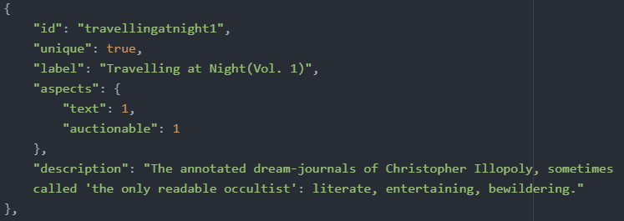

Example of an element (a book)

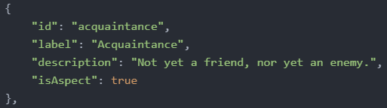

Example of an aspect (“acquaintance”)

## Decks

Decks are collections of nouns. They are a list of shuffled non-aspect elements (cards) that can be drawn by recipes during their execution. They can be reshuffled on exhaustion, or not.

“Deck” can refer to the *deck state* (a list of cards in a set order and a list of forbidden cards, which is stored in the game’s save files and does not persist across playthroughs), or the *deck object* (which is all the data about *every* instance of a given deck, regardless of what part of which game it may be from… unless the object is changed after the state is made). This distinction is important when decks are modified mid-game: the deck object is changed, but the deck state is not. Cards that might have been removed from the deck object may still be in the deck state, and cards added to the deck object will not be added to the deck state.

Deck states keep track of unique cards (either cards where unique = true, or where the ‘uniquenessgroup’ property is defined) that already exist: when a unique card is generated anywhere in the game, it, and all elements that share a uniqueness group with it, are added to a forbidden list on all decks that contain that element or group. If a card is in a deck state’s forbidden list, it is removed from the deck’s draw list, and will never be shuffled back into the draw list for the rest of that game. This way, duplicate unique cards can not be drawn from decks.

### 

### Properties of Decks

#### Slot ID

| Property name | id |
| --- | --- |
| Explanation | Internal name of Deck. |
| Default value | No default value. **This property is mandatory.** |
| **Examples** | |
| Simple use of the property | {  "id": "myid"  } |

#### Label

| Property name | label |
| --- | --- |
| Explanation | Displayed name of the deck. |
| Default value | "" |
| **Examples** | |
| Simple use of the property | {  "id": "myid",  "label": "Some label"  } |

#### 

#### Description

| Property name | description |
| --- | --- |
| Explanation | Text displayed in the top right when the deck draw icon is clicked on. |
| Default value | "" |
| **Examples** | |
| Simple use of the property | {  "id": "myid",  "description": "Some description"  } |

#### Reset on Exhaustion

| Property name | resetonexhaustion |
| --- | --- |
| Explanation | Whether or not the deck will be reshuffled after all cards have been drawn. Any unique cards in the deck will not be shuffled back in. **Must be true if no** **defaultcard** **property is set.** |
| Default value | false |
| **Examples** | |
| Simple use of the property | {     "id": "myid",     "resetonexhaustion": true } |

#### 

#### Spec (list of cards)

| Property name | spec |
| --- | --- |
| Explanation | The actual list of elements to draw from. There can be duplicates of cards: this is often used to influence the probability of one card to be drawn. This cannot be used to allow a given unique card to be drawn more than once (as when the unique card is drawn, all other instances of it in decks are removed).  This property must be defined and not empty, unless defaultcard is defined. |
| Default value | [] |
| **Examples** | |
| Simple use of the property |  |

#### 

#### Default Card

| Property name | defaultcard |
| --- | --- |
| Explanation | Once the deck has been exhausted, if the deck does not reset, this card is the only card that can be drawn from then on. This is **required** if your deck doesn’t reset - your mod will not execute otherwise. |
| Default value | "" |
| **Examples** | |
| Simple use of the property |  |

#### Draw Messages

| Property name | drawmessages |
| --- | --- |
| Explanation | A dictionary of element names with messages to be displayed once those cards are revealed. Used for the Mansus rather than standard deck draws. (Cannot be used outside of Mansus decks.) |
| Default value | {} |
| **Examples** | |
| Simple use of the property |  |

#### 

#### 🐓 Shuffle after draw

| Property name | shuffleAfterDraw |
| --- | --- |
| Explanation | If this property is set to true, the deck will be reshuffled after each draw instruction. **It is reset after the number of cards specified in the instruction, not after each card**. For example, a deckeffects property in a recipe with the value of 2 will only reshuffle it after both cards are drawn. |
| Default value | false |
| **Examples** | |
| Simple use of the property | {     "id": "myid",     "shuffleAfterDraw": true } |

#### 

## 

## Recipes

### Description

Recipes take nouns (cards), and a verb, and combine them into something that makes sense. On their own, the cards “Neville” and “The Forgotten Mithraeum” cannot do anything, and likewise in isolation the verb “Explore” is meaningless. However, a recipe can link them together into something that has meaning: “Neville exploring the forgotten mithraeum”.

From a gameplay perspective, recipes are a nugget of logic. They receive cards, display some text while they warm up, then do something with them, by executing some actions (drawing cards from decks, for instance) and finally either stop or give their result to a recipe linked to run after this one. Recipes are chained together to create more complex actions.

### Order of Effects

Many recipe properties add, remove, or cause changes to elements contained within the recipe at its conclusion, or they assess these values to determine what happens next. Recipe properties execution takes place in a certain order. (This is partially tentative, and may need updates as further tests are done.)

Recipe Start: Slots open, and burn images are displayed.

Alternative recipes are checked, including alt-additional recipes. For each alternative recipe, a random number between 1 and 100 is generated. If that number does not *exceed* the execution chance of an alt recipe (which defaults to 100), it is considered as a possible alternative recipe during the warmup, or is added to a list of alt-additional recipes to be executed, as appropriate.

During the warmup, recipes whose chances were met will have their requirements reassessed each time a card is placed into or removed from the active slot. This will cause burn images to trigger if the alt recipe has a burn image, and will update the label, description, and loop importance of the Verb if appropriate.

When the warmup timer ends, the active recipe (either a non-additional alt recipe or the base recipe) is “locked in”, and its properties are applied in the following order:

Mutations -> XTriggers from recipe aspects -> XTriggers from elements in the Verb -> deck effects -> effects -> Verb halt -> Verb delete -> purges -> slot consumptions -> endings.

After that, alt-additional recipes are spawned, but *only if their requirements were met at the start of the recipe* (when all alts are evaluated) - any element/aspect that appeared during recipe effects will not affect whether alt-additionals fire or not. All expulsions also happen here (as expulsions are part of the firing of alt-additional recipes), so expelled elements are affected by xtriggers/mutations, and any changes in cards can affect what will be expelled. Expelled elements are not evaluated for links’ requirements. (When deciding which of multiple qualifying elements to expel, the game always chooses the card that has been in the Verb/situation the longest.)

After these, linked recipes are assessed. If none are found, the situation/recipe chain ends, and inductions are triggered, followed by portal (Mansus) effects. Inductions only trigger on face-up cards, so if a card has just been issued via effects or deck effects, it cannot trigger inductions, unless it has a lifetime (cards with lifetime are always face-up), or it is issued in a recipe prior to the final recipe, then xtriggered, which will cause it to be flipped over.

### Properties of Recipes

#### Recipe ID

| Property name | id |
| --- | --- |
| Explanation | This is the internal identifier for the recipe, you will always use this to reference the recipe. |
| Default value | No default value. **This property is mandatory.** |
| **Examples** | |
| Simple use of the property | {  "id": "myrecipeid"  } |

#### 

#### 

#### Action ID

| Property name | actionId |
| --- | --- |
| Explanation | This is the id of the verb to use for this recipe. **It is mandatory on craftable recipes**, because the game has to know which verb this recipe is supposed to be started with.  It is also mandatory for recipes used as additional induced recipes (see further down the guide), as they'll be started into a new verb, this property defines the id of the verb to spawn and handle them.  For induced recipes, this ID doesn't have to refer to a JSON-defined verb. If it doesn't, it will spawn a "temporary verb", that will disappear once it has finished running and its content is collected (e.g the seasons).  If a non-idle instance of the verb is already present on the board, it cannot be spawned again. This will result in the recipe not being executed at all, and no new verb will spawn. |
| Default value | No default value. |
| **Examples** | |
| Simple use of the property |  |

#### 

#### 

#### Craftable (can it be started manually by the player?)

| Property name | craftable |
| --- | --- |
| Explanation | This boolean property controls whether the player can manually start this recipe by putting the right cards into a verb's slots. **Recipes marking the beginning of an action by the player must have this value set to true**.  Recipes that have this value set to false can be linked by other recipes. |
| Default value | False (the recipe cannot be started by the player by default) |
| **Examples** | |
| Simple use of the property | {    "id": "myrecipe",    "craftable": true } |

#### 

#### Maximum Number of Executions

| Property name | maxexecutions |
| --- | --- |
| Explanation | This is the maximum number of times a recipe can be executed. Every recipe is tracked whether it has this property or not, but this is the only evaluation that can be made against that value. |
| Default value | Undefined (the recipe will always be potentially valid to execute) |
| **Examples** | |
| Simple use of the property | {    "id": "myrecipe",    "maxexecution": 2 } |

#### 

#### Hint Only?

| Property name | hintonly |
| --- | --- |
| Explanation | This disables the start button but still displays the recipe when true if its requirements are met. If the requirements for a hint recipe and a normal, craftable recipe are both met, the normal recipe takes precedence. Hintonly recipes do not need to also have craftable set to true. |
| Default value | False (the recipe isn't a hint by default) |
| **Examples** | |
| Simple use of the property |  |

#### 

#### 

#### Warmup Time

| Property name | warmup |
| --- | --- |
| Explanation | This is the duration of the timer that counts down after starting a recipe, in seconds.  If the recipe is executed as an Alternative Recipe, this property is not needed, and will be ignored.   |  | **Infinitely Looping 0 warmup recipes lead to a crash**  Recipes can link to themselves or even form a loop with other recipes. This loop has to contain at least 1 non-zero warmup somewhere in it, or be certain it'll stop at some point. Otherwise, the game will crash.  This happens because when executing instantaneous recipes, the game tries to execute all the next instantaneous recipes in one batch. If this list of recipes to execute right now is infinite, the game crashes.  Instantaneous loops that end, and non-instantaneous loops that never end, are fine. | | --- | --- | |
| Default value | 0 (the recipe is instantaneous) |
| **Examples** | |
| Simple use of the property | {    "id": "myrecipe",    "warmup": 2 } |

#### 

#### 

#### Label

| Property name | label |
| --- | --- |
| Explanation | This is the name of the recipe that is displayed to the player as the title of the Verb's window.  Labels support up to 1 refinement block.   |  | **Additional features on this property**  Labels can contain multiple refinement blocks. They cannot be nested, but you can use multiple in the same label.  *What is this Bird?* | | --- | --- | |
| Default value | "" (empty string) |
| **Examples** | |
| Simple use of the property | {  "id": "myid",  "label": "Doing Something"  } |

#### 

#### 

#### Slots

| Property name | slots |
| --- | --- |
| Explanation | This is basically the slot for a Quick Time Event that is available when the recipe is warming up, usually used to give the players input on a decision for the recipe. Such as the decision for a rebellious spirit, either supplying a reason or passion or choosing to ignore it completely. Contrary to what the name suggests, recipes can have only one slot, **see the Slots section for more information**.   |  | **Additional features on this property**  In The Roost Machine, the slots property supports up to 3 slots and will display them all next to each other on a single row, during the warmup.  *What is this Bird?* | | --- | --- | |
| Default value | [] (empty list, no slot displayed) |
| **Examples** | |
| Simple use of the property | {    "id": "myrecipe",    "actionId": "talk",    "slots": [       {          "id": "slot1",          "label": "Some Slot"       }    ] } |

#### 

#### 

#### Start Description

| Property name | startdescription |
| --- | --- |
| Explanation | This is the description displayed before the recipe is started and during the warmup.  This property supports up to 1 refinement block.   |  | **Additional features on this property**  startdescription can contain multiple refinement blocks. They cannot be nested, but you can use multiple in the same label.  *What is this Bird?* | | --- | --- | |
| Default value | "" (empty string) |
| **Examples** | |
| Simple use of the property | {  "id": "myid",  "actionId": "explore",  "startdescription": "I would like going on a walk.",  "description": "This was a pleasant walk."  } |

#### 

#### 

#### Description

| Property name | description |
| --- | --- |
| Explanation | This is the description displayed after the recipe has been completed. This text is never displayed if the recipe routes to another linked recipe, as the action is not considered completed until a recipe ends without starting another one.  This property supports up to 1 refinement block.   |  | **Additional features on this property**  startdescription can contain multiple refinement blocks. They cannot be nested, but you can use multiple in the same label.  *What is this Bird?* | | --- | --- | |
| Default value | "" (empty string) |
| **Examples** | |
| Simple use of the property | {  "id": "myid",  "actionId": "explore",  "startdescription": "I would like going on a walk.",  "description": "This was a pleasant walk."  } |

#### 

#### 

#### Requirements

| Property name | requirements |
| --- | --- |
| Explanation | This is an inclusive set of conditions that is evaluated whenever the recipe is encountered in a recipe link to decide whether or not to execute the recipe. The list of elements (and aspects) must all be present within the recipe’s element stack.  This can also be used comparatively, having a requirement of "element_1" : "element_2" requires that you have a greater than or equal quantity of "element_1" as "element_2". Furthermore, negative numbers are allowed, and function as "less than", allowing -1 to represent 0, -2 to represent having 1 or 0, etc.   |  | **Additional features on this property**  The amounts can only be defined by a value, or the id of an element, and always only reference things that are in the verb. Use the grandReqs property for more flexibility.  *What is this Bird?* | | --- | --- | |
| Default value | {} (no requirements) |
| **Examples** | |
| Simple use of the property | {    "id": "myrecipe",    "actionId": "talk",    "startdescription": "I would like going on a walk.",    "description": "That was a pleasant walk.",    "requirements": {       "health": 1    } } |
| Use of the comparative syntax | {    "id": "myrecipe",    "actionId": "talk",    "startdescription": "I would like going on a walk.",    "description": "That was a pleasant walk.",    "requirements": {       "health": "lantern"    } } |
| Use of a negative value |  |

#### 

#### 

#### Table Requirements

| Property name | tablereqs |
| --- | --- |
| Explanation | This is an inclusive set of conditions that is evaluated whenever the recipe is encountered in a recipe link to decide whether or not to execute the recipe.  The list of elements (and aspects) must all be present **on the game board**, not in a Verb tile. Elements in idle verbs (not started, completed actions) are also considered "on the board". Elements in slots displayed during warmups are also taken into account, if they're not greedy slots.  **Rule of thumb**: if the player can take it, drag it, it's taken into account by tablereqs (hence the exception for the greedy slots).  Like requirements, tablereqs support the less than symbol and comparisons.   |  | **Additional features on this property**  The amounts defined in the dictionary can only be defined by a value, or the id of an element. Use the grandReqs property for more flexibility.  *What is this Bird?* | | --- | --- | |
| Default value | {} (no requirements) |
| **Examples** | |
| Simple use of the property |  |

#### Extant Requirements

| Property name | extantreqs |
| --- | --- |
| Explanation | This is an inclusive set of conditions that is evaluated whenever the recipe is encountered in a recipe link to decide whether or not to execute the recipe.  The list of elements (and aspects) must all be present **somewhere within the game**. They can be in another recipe, in the player’s hand, or on the board.  Like requirements, extantreqs support the less than symbol and comparisons.   |  | **Additional features on this property**  The amounts defined in the dictionary can only be defined by a value, or the id of an element. Use the grandReqs property for more flexibility.  *What is this Bird?* | | --- | --- | |
| Default value | {} (no requirements) |
| **Examples** | |
| Simple use of the property |  |

#### 

#### 

#### Effects

| Property name | effects |
| --- | --- |
| Explanation | This is a set of elements to add or remove from the content of the verb.  When the amount is positive, this amount of the element is added. When the amount is negative, up to this amount of the valid cards to remove is removed. When using a negative value, the cards considered for removal are all the cards with this id, or possessing that id in their aspects.  Comparisons are also available for effects (e.g. "health": "forge" will create as many health cards as the amount of the forge aspect in the verb).   |  | **Additional features on this property**  The amounts defined in the dictionary can be expressions.  *What is this Bird?* | | --- | --- | |
| Default value | {} (no effects) |
| **Examples** | |
| Simple use of the property |  |

#### 

#### Purge

| Property name | purge |
| --- | --- |
| **Explanation** | |
| This is a set of operations to apply to the game board. It will decay up to the specified amount of the element sources. If a specific element type is specified, it will decay to whatever is indicated in that element's "decayTo" property, even if the element has no lifetime to cause it to decay naturally. If no element is specified under "decayTo", the element will be destroyed. If Purge is used on an aspect, all elements with the aspect will normally be destroyed since aspects do not normally have a decayTo property. However, if for some reason the aspect does have a decayTo property, then instead of destroying elements with the aspect, elements with the aspect will be decayed. This works well because the element that the aspect has been set to decayTo will be ignored; instead, each element that has the aspect will decay according to its own decayTo aspect. If the individual element has no decayTo aspect, then it is destroyed.   |  | WIP SECTION, UNDER REWRITE | | --- | --- | |  |  | |  |  |  |  | **Made obsolete by a new property**  For Roost users, the decays property does exactly the same thing, without its quirks. It triggers the decay of all the matched elements (direct ID or possessed aspect).  *What is this Bird?* | | --- | --- | | |
| Default value | {} (no purge) |
| **Examples** | |
| Simple use of the property |  |

#### 

#### Aspects

| Property name | aspects |
| --- | --- |
| Explanation | This is a set of aspects applied just during the resolution of this recipe. This is usually used to introduce temporary aspects **for the purpose of triggering an XTrigger reaction** (for more information check the elements reference detailing what xtriggers are), since the aspects disappear after the recipe ends, and don't proc inductions.   |  | **Additional features on this property**  The amounts defined in the dictionary can be expressions.  *What is this Bird?* | | --- | --- | |
| Default value | {} (no aspects applied) |
| **Examples** | |
| Simple use of the property | {    "id": "myrecipe",    "actionId": "talk",    "startdescription": "I would like going on a walk.",    "description": "That was a pleasant walk.",    "aspects": {       "notoriety": 1    } } |

#### 

#### 

#### Deck Effects

| Property name | deckeffects |
| --- | --- |
| Explanation | This is a set of deck IDs that are drawn from the specified number of times and added to the elements in the verb, at the conclusion of the recipe.   |  | **Additional features on this property**  The amounts defined in the dictionary can be expressions.  *What is this Bird?* | | --- | --- | |
| Default value | {} (no deck drawn from) |
| **Examples** | |
| Simple use of the property | {    "id": "myrecipe",    "actionId": "talk",    "startdescription": "I would like going on a walk.",    "description": "That was a pleasant walk.",    "deckeffects": {       "somedeck": 3    } } |

#### 

#### 

#### Halt Verb

| Property name | haltverb |
| --- | --- |
| Explanation | This property stops the specified verbs up to the given number of different tokens. The recipe currently warming up inside it concludes and displays its description text. The linked and alt properties aren't evaluated.  The ids written can be ended by the * symbol, to signify "any verb with the id starting with this string" (see examples below). The amount assigned really only makes sense when used with this wildcard symbol, otherwise just set it to 1. |
| Default value | {} (no verb halted) |
| **Examples** | |
| Simple use of the property |  |
| Use of the wildcard (*) |  |

#### 

#### Delete Verb

| Property name | deleteverb |
| --- | --- |
| Explanation | This property stops the specified verbs up to the given number of different tokens and immediately deletes it and its content.  The ids written can be ended by the * symbol, to signify "any verb with the id starting with this string" (see examples below). The amount assigned really only makes sense when used with this wildcard symbol, otherwise just set it to 1. |
| Default value | {} (no verb deleted) |
| **Examples** | |
| Simple use of the property |  |
| Use of the wildcard (*) |  |

#### 

#### 

#### Internal Deck

| Property name | internaldeck |
| --- | --- |
| Explanation | This lets you define a deck directly inside a recipe, usually for its personal use, instead of defining a deck object in another JSON file. Using this property is generally not recommended for readability reasons, but it is ultimately a matter of taste. |
| Default value | {} (no deck defined) |
| **Examples** | |
| Simple use of the property |  |

#### 

#### Signal Important Loop

| Property name | signalimportantloop |
| --- | --- |
| Explanation | This boolean property makes the game play a loud sound to let the player know something important is happening. You can see it used in the "needs" recipe of the Time verb. |
| Default value | false |
| **Examples** | |
| Simple use of the property |  |

#### 

#### Ending

| Property name | ending |
| --- | --- |
| Explanation | This property defines the ending of the ID to trigger when this recipe concludes. |
| Default value | "" (no ending triggered) |
| **Examples** | |
| Simple use of the property |  |

#### 

#### Signal Ending Flavour

| Property name | signalEndingFlavour |
| --- | --- |
| Explanation | This will change the colour of the warmup circle around the verb, and trigger fancy music. If it is not one of the predefined and hardcoded values it won't do anything. The predefined values are:   * Grand for a golden effect * Melancholy for a red effect * Pale for a white effect * Vile for an edge-green effect |
| Default value | "" (no signal) |
| **Examples** | |
| Simple use of the property |  |

#### 

#### 

#### Achievements

| Property name | achievements |
| --- | --- |
| Explanation | This property defines the list of achievements to unlock when this recipe concludes. |
| Default value | [] (no achievement unlocked) |
| **Examples** | |
| Simple use of the property |  |

#### 

#### Burn Image

| Property name | burnimage |
| --- | --- |
| Explanation | This will display the defined image file as a "burn image" on the table, when the recipe begins its warm up. The image must be located in "images/burns" and be a PNG file. |
| Default value | "" |
| **Examples** | |
| Simple use of the property |  |

#### 

#### 

#### Portal Effect

| Property name | portaleffect |
| --- | --- |
| Explanation | This property tells a recipe to transition into the Mansus and which door to open to, when its warm up concludes. This causes the recipe to draw a card from each deck associated with the door and let you choose from them on the board. |
| Default value | "" (no portal effect) |
| **Examples** | |
| Simple use of the property |  |

#### 

#### 

#### Mutations

| Property name | mutations |
| --- | --- |
| Explanation | This property is a list of mutations. Mutations are used to add or remove aspects from an element contained in the verb. Mutated aspects remain even when the element changes via xtrigger or decay. There are a few properties needed to set a mutation:   * Filter ("filter") - used to find the element that will be modified. Filters can be elements or aspects. * Mutation Aspect ("mutate") - the aspect we are adding/removing on the element. * Level ("level") - a positive or negative value to represent how much of the given aspect we are adding or taking away. * Additive ("additive") - a boolean value that decides whether this change replaces the stated value with the current one, or adds/subtracts the value from the base element's values. This defaults to false.  |  | **Additional features on this property**  The "filter" and "level" properties can be expressions. Also, an additional property named "limit" lets you limit how many elements at most will be targeted by the mutation.  *What is this Bird?* | | --- | --- | |
| Default value | [] (no mutation) |
| **Examples** | |
| Simple use of the property |  |

#### 

#### 

#### Linked Recipes

| Property name | linked |
| --- | --- |
| **Explanation** | |
| A list of candidate recipe links to be looked at in order to find the next recipe to run, after the current recipe is resolved.  Each candidate in the list is a "recipe link", an object defined by a few properties:   | id | The ID of the recipe to be executed | | --- | --- | | chance | A number from 0 to 100, inclusive. Represents the percent chance of the recipe executing | | challenges | A way of determining chance based on how much of a given aspect is currently in the recipe. First you declare an aspect, then you declare the challenge to be a "base" or "advanced" challenge, which represent different statistical chances.   * "base" challenges have 0% chance for 0 aspect, 30% chance for 1, 70% chance for 5, and 90% chance for 10. * "advanced" challenges have 0% chance for 0 aspect, 10% chance for 5, 30% chance for 10, 70% chance for 15, 90% chance for 20. |   If challenges and chance are used, the **challenges** propertyoverwrites the chance property. If no challenge is defined and no chance is defined, chance is 100%.  Each recipe link is resolved from first to last. The first to be a valid recipe to execute (based on the chance property and the actual recipe's requirements) is selected to be the next recipe and the others are ignored. This followup recipe is immediately started.   |  | **The ID property can be ended by a wildcard (*)**  The id property of a recipe link can end with the wildcard (*) symbol. When written that way, the game will compile the list of all matching recipe IDs starting with this ID ("myrecipe*" will match "myrecipe", "myrecipehard", "myrecipecool"), sorted by definition order.  It will then resolve the requirements of each, one by one, and the first valid recipe will be picked to be the next recipe to run. | | --- | --- |  | **Additional features on this property**  If you don't need to define other properties but the id, you can define a recipe link by just a string that is the id of the recipe, you don't have to define an entire object that only contains an "id" property.  Recipe links also have additional properties on them:   | randomPick | Boolean property. When using an id wildcard, the selection process behaves differently: instead of picking the first valid recipe in the "list of matching recipe IDs", it will first validate them all, then pick one among the valid ones, at random. | | --- | --- | | randomPickChances | A set of recipe IDs associated to a chance value, used when randomPick is used. When a random recipe is selected, if the recipe ID is in the randomPickChances set, runs a chance test with the defined value to determine if the recipe is valid or not, even if its requirements are met. | | useCallback | This property defines the name of a callback. When this recipe link is resolved, if it defines this property, and the callback it names has been defined, it will return the callback recipe as the valid one. **In practice, this is how callbacks let a recipe "return" or "jump" to a previously defined recipe.** |   *What is this Bird?* | | | --- | --- | --- | --- | --- | --- | --- | --- | | |
| Default value | [] (no links; the recipe-chain will always stop after this recipe concludes) |
| **Examples** | |
| Simple use of the property |  |

#### 

#### Induced Recipes

| Property name | inductions |
| --- | --- |
| **Explanation** | |
| A list of candidate recipe links to be evaluated, and if valid to start, "induced" (started) in their own verb. If an active existing instance of the verb already exists, the spawning won't happen. If the recipe's requirements aren't met, the spawning won't happen either.  Each candidate in the list is an "induction recipe link", an object defined by a few properties:   | id | The ID of the recipe to be executed | | --- | --- | | chance | A number from 0 to 100, inclusive. Represents the percent chance of the recipe executing | | challenges | A way of determining chance based on how much of a given aspect is currently in the recipe. First you declare an aspect, then you declare the challenge to be a "base" or "advanced" challenge, which represent different statistical chances.   * "base" challenges have 0% chance for 0 aspect, 30% chance for 1, 70% chance for 5, and 90% chance for 10. * "advanced" challenges have 0% chance for 0 aspect, 10% chance for 5, 30% chance for 10, 70% chance for 15, 90% chance for 20. | | expulsion | This is a dictionary of filters and limits. An expulsion will try to grab up to the specified number of the source of the specified element in the filter. It will grab either cards or cards with the element as an aspect. Once it has grabbed all the cards it can, it will carry them into the newly spawned verb. |   If challenges and chance are used, the **challenges** propertyoverwrites the chance property. If no challenge is defined and no chance is defined, chance is 100%.  Each recipe link is resolved from first to last. All the recipe links found valid to induce are induced. | |
| Default value | [] (no links; no induction) |
| **Examples** | |
| Simple use of the property |  |

#### 

#### Alternative Recipes

| Property name | alt |
| --- | --- |
| **Explanation** | |
| A list of candidate recipe links to be evaluated. Every time the content of the verb changes, the recipe links are evaluated again for a valid recipe (the first valid recipe is picked). If a valid recipe is found, its label and startdescription properties are displayed, and on completion its set of effects is the one applied (+ the linked property used to find the next recipe to run). The countdown isn't modified though. This property can be used to have a recipe display a different text and have a different effect based on what the player puts in the warmup slot.  Each candidate in the list is a "alt recipe link", an object defined by a few properties:   | id | The ID of the recipe to be executed | | --- | --- | | chance | A number from 0 to 100, inclusive. Represents the percent chance of the recipe executing | | challenges | A way of determining chance based on how much of a given aspect is currently in the recipe. First you declare an aspect, then you declare the challenge to be a "base" or "advanced" challenge, which represent different statistical chances.   * "base" challenges have 0% chance for 0 aspect, 30% chance for 1, 70% chance for 5, and 90% chance for 10. * "advanced" challenges have 0% chance for 0 aspect, 10% chance for 5, 30% chance for 10, 70% chance for 15, 90% chance for 20. | | additional | Makes this alt recipe link behave like a recipe link defined in the inductions property.   |  | **Legacy property**  Documented only for historic reasons. It is not recommended to use it, prefer the more modern inductions recipe property if you wish to trigger inductions. | | --- | --- | | | expulsion | This is a dictionary of filters and limits. An expulsion will try to grab up to the specified number of the source of the specified element in the filter. It will grab either cards or cards with the element as an aspect. Once it has grabbed all the cards it can, it will carry them into the newly spawned verb.   |  | **Legacy property**  Documented only for historic reasons. It is not recommended to use it, prefer the more modern inductions recipe property if you wish to trigger inductions. | | --- | --- | |   If challenges and chance are used, the **challenges** propertyoverwrites the chance property. If no challenge is defined and no chance is defined, chance is 100%.  Each recipe link is resolved from first to last. All the recipe links found valid to induce are induced. | |
| Default value | [] (no alt) |
| **Examples** | |
| Simple use of the property |  |

#### Xpans

| Property name | xpans |
| --- | --- |
| **Explanation** | |
| A list of aspects to be applied to all “exterior spheres” (i.e. all cards the player can interact with), similar to recipe aspects but with a different scope. Essentially, it is a way to trigger xtriggers on the whole table. | |
| Default value | [] (no alt) |
| **Examples** | |
| Simple use of the property |  |

#### 

#### 🐓 Preview Label

| Property name | previewLabel |
| --- | --- |
| Explanation | If defined, this text will be displayed as the recipe's label **before the recipe is started by the player.** It lets you define a different label from the one displayed during the warmup. If no previewLabel is defined, the label property will be displayed instead.  previewLabel supports refinement blocks. |
| Default value | "" (empty string). |
| **Examples** | |
| Simple use of the property | {  "id": "myid",  "actionId": "explore",  "previewLabel": "Going For a Walk?",  "label": "A Pleasant Walk"  } |

#### 

#### 

#### 🐓 Preview Description

| Property name | previewDescription |
| --- | --- |
| Explanation | If defined, this text will be displayed as the recipe's description **before the recipe is started by the player.** It lets you define a different description from the one displayed during the warmup. If no previewDescription is defined, the startdescription property will be displayed instead.  previewDescription supports refinement blocks. |
| Default value | "" (empty string). |
| **Examples** | |
| Simple use of the property | {    "id": "myrecipe",    "actionId": "talk",    "previewLabel": "Going for a Walk?",    "previewDescription": "I could go on a walk." } |

#### 

#### 🐓 Grand Reqs

| Property name | grandReqs |
| --- | --- |
| Explanation | This property works like the other requirement properties, it takes a set of element ids and quantities, but the element side can reference any context, and the right side can be a Fucine expression (see examples below).  This lets you compare any amount of something in any context, against a dynamically computed value that can use references in any context. |
| Default value | {} (no reqs) |
| **Examples** | |
| Use with an expression for the quantity |  |
| Use with a reference |  |

#### 

#### 🐓 Furthermore

| Property name | furthermore |
| --- | --- |
| Explanation | This property lets you execute a series of "recipe effects'' when the recipe's warm up completes. Each object in the list can contain exactly the same "recipe effects" (effects, deckeffects, aspects, mutations, haltverb, …) recipes support. This can be used to run a series of effects in a single recipe where the order of effects wouldn't have played nicely by default.  In addition to the usual properties, each object can define a target property to specify in which context it should apply (see examples below). This lets you apply things directly to the board from inside a verb, or apply things to the content of another running verb. |
| Default value | [] (no effects) |
| **Examples** | |
| Simple use with no target | {  "id": "mariner.spawn.crewmember.intellectual",  "furthermore": [  {  "deckeffects": {  "mariner.decks.specialists.opportunities.intellectual": 1  }  },  {  "aspects": {  "mariner.paidopportunity": 1  }  }  ]  } |
| Use with targets. Here, each set of effects is applied after the other, to ~/exterior (the table). | {  "id": "mariner.discoverbar.northsea.copenhagen",  "furthermore": [  {  "target": "~/exterior",  "mutations": {  "mariner.nobarhere": {  "mutate": "mariner.discoveredbars.northsea.copenhagen"  }  }  },  {  "target": "~/exterior",  "decays": ["mariner.nobarhere"]  },  {  "target": "~/exterior",  "aspects": {  "mariner.displaylocalbar.northsea.copenhagen": 1  }  }  ]  } |

#### 

#### 🐓 Decays

| Property name | decays |
| --- | --- |
| Explanation | This property works like purge but without the strange behaviours. It triggers the decaying of the listed elements, or, if the id is an aspect, the elements having it as an aspect. If the element doesn't have a decayTo property, it is destroyed instead.  It is a list of things to decay. Each thing in the list can be written following two syntaxes:   * A simple string. It is an expression, and can simply be an element ID. All the matching elements will be purged. * An object, with two properties, "filter" and "limit". The filter property is the matching expression, and the limit property is how many elements to purge, maximum (see example below). |
| Default value | [] (nothing to purge) |
| **Examples** | |
| Three different examples of use of the property | {   "id": "mariner.discoverbar.northsea.copenhagen",   "decays": [     "lantern",     { "limit": 3, "filter": "forge" },     { "edge || winter": 3 }   ] } |

#### 

#### 🐓 Add Callbacks

| Property name | addCallbacks |
| --- | --- |
| Explanation | This property lets you store, for the duration of the recipe-chain, a "callback", a recipe ID associated with an arbitrary name.  Further down the recipe-chain, if a linked property uses a useCallback property, it may read it and select the associated callback as the next recipe to execute, making it "jump" to where you designed the callback to go.  This property is additive. If a set of callbacks was already defined during the recipe-chain, defining a callback with the same name will overwrite an existing one, but the others won't be cleared. For that, use clearCallbacks or resetCallbacks. |
| Default value | {} (no callback set) |
| **Examples** | |
| Simple use of the property |  |

#### 

#### 🐓 Clear Callbacks

| Property | clearCallbacks |
| --- | --- |
| Explanation | This property clears potentially previously defined callbacks. It is a list of the callback names to clear. |
| Default value | [] (no callback cleared) |
| **Examples** | |
| Simple use of the property |  |

#### 🐓 Reset Callbacks

| Property | resetCallbacks |
| --- | --- |
| Explanation | This boolean property clears all the callbacks previously defined during the current recipe-chain. |
| Default value | False (don't reset) |
| **Examples** | |
| Simple use of the property |  |

#### 

#### 🐓 Save Checkpoint

| Property | saveCheckpoint |
| --- | --- |
| Explanation | Doesn't do anything if the current legacy has the useCheckpoints property set to false.  Will save a checkpoint to this exact moment, and display a notification to tell the player about it. When an ending is reached, if the legacy allows it and a checkpoint is found, an additional button to reload the last checkpoint is displayed. If the player leaves the game or restarts a new one, the checkpoint is lost. |
| Default value | False (no saving) |
| **Examples** | |
| Simple use of the property |  |

#### 

#### 🐓 Change the Background Tracklist

| Property | setBGMusic |
| --- | --- |
| Explanation | Defines a new set of tracks to use as the background music. The files must be mp3 audio files placed in a folder named "audio" at the root of the mod.  **The file names must be written with their file extension.**  This change doesn't trigger an immediate music change, the new tracklist will be used when picking the next track after the current one ends. |
| Default value | [] (no change) |
| **Examples** | |
| Simple use of the property |  |

#### 🐓 Play Audio Track

| Property | playAudioTrack |
| --- | --- |
| Explanation | Triggers a background music change (fade-out fade-in). The track doesn't have to be part of the current tracklist. After playing this one, the game will go back to the current tracklist.  **The file name must be written with the file extension.** |
| Default value | "" (no track to play) |
| **Examples** | |
| Simple use of the property |  |

#### 

#### 🐓 Movements

| **Property** | movements |
| --- | --- |
| **Explanation** | |
| Lets you move a set of matching elements from the current verb to any destination. The property is a set of Fucine Paths describing the destination, associated to a either an element id (or expression), or a more complex object describing which cards to move and how many at most:   | filter | An element ID. Can be an expression. | | --- | --- | | limit | How many cards to move at most. |   If instead of an entire object, you only provide a string (element ID or expression), then there's no limit and the default destination is the table.  If you wish to move different sets of elements with different limits, you can instead associate a list of objects to the Fucine Path.  Check the examples to get a better idea of the syntax. | |
| Default value | {} (no movements) |
| **Examples** | |
| "Move all cards having the lantern aspect"  Simplest form: path associated to the expression (here, a simple aspect). |  |
| "Move at most 2 cards having the lantern aspect"  Syntax using an object to define more specific information. |  |
| "Move at most 1 lantern and 1 forge card to the table".  Syntax using a list to define multiple movements. |  |
| "Move a single card that has either Lantern or Forge aspect to the Table" |  |
| "Move all the mortals from here to the "hunters" deck" |  |

#### 

#### 🐓 Change Table Image

| Property | tabletopImage |
| --- | --- |
| Explanation | Fades the current tabletop sprite to a new one. The image has to be placed in the images/ui folder. |
| Default value | "" |
| **Examples** | |
| Simple use of the property |  |

#### 🐓 Change Table Leather

| Property | tableLeather |
| --- | --- |
| Explanation | Fades the current table leather sprite to a new one. The image has to be placed in the images/ui folder. |
| Default value | "" |
| **Examples** | |
| Simple use of the property |  |

#### 🐓 Change Table Legs

| Property | tableLegs |
| --- | --- |
| Explanation | Fades the current table legs sprite to a new one. The image has to be placed in the images/ui folder. |
| Default value | "" |
| **Examples** | |
| Simple use of the property |  |

#### 🐓 Root Effects

| Property | rootEffects |
| --- | --- |
| Explanation | Applies the equivalent of the "effects" property to the root. The root is a "sphere", like "tabletop" is. You can consider it to be a second global table, available from anywhere, not affected by greedy slots and things like that.  This property is usually used to store/read global information that you do not want to store on the table as a visible card (think progression flags, hidden progress, ...)   |  | **How to read the root**  To read what's stored in the root, use the root/ sphere path in the expressions. See examples below. | | --- | --- | |
| Default value | {} (no effect applied) |
| **Examples** | |
| Simple use of the property | {     "id": "somerecipe",     "rootEffects": {         "myelement": 1     } } |
| How to read the state of the root in grandReqs | {     "id": "somerecipe",     "grandReqs": {         "root/myelement": 1     } } |

#### 🐓 Deck Shuffles

| Property | deckShuffles |
| --- | --- |
| Explanation | Shuffles the listed decks. |
| Default value | [] |
| **Examples** | |
| Simple use of the property | {  "id": "somerecipe",  "deckShuffles": [  "deck1",  "deck2",  "deck3"  ]  } |

#### 

Undocumented recipe properties to add:

| Ready to document | 🐓burnimages, 🐓vfx, 🐓mutations alternative syntax |
| --- | --- |
| Needs more info | 🐓setLeversCurrent, 🐓setLeversFuture |
| Roost additions to document:  New expressions area - "entity". Returns the quantity of a token if its entity matches the mask - "entity/introjob", "entity/fragmentlantern", "entity/fragment*".  It's now possible to check aspects in the current situation's slots with ~/situation/slots/[slotid]. For example: '[~/situation/slots/work:job]>=1'  Slots have a new property: addsSlots. By default, only a card in the first slot of a verb contributes to the new slots appearing. Now, anything in the slot that has addsSlots: true contributes too.  Verbs have a new property: stickySlots. Setting it to true means that the verb won't empty all its slots on closing. This allows to have a dynamic player-controlled "storage".  Fucine expressions support a new value scope - container: "~/[threshold]+:container/lantern". This is fairly niche, the purpose is basically to allow accessing aspects of a verb when targeting a slot. A more formal definition is "returns an aspect value of a token, that contains a sphere, in which the target token is", in case it says something to someone.  Three new reference operations:  -- 'achievement' - returns 1 if an achievement with a specified id exists and is unlocked. Returns 0 otherwise. Works for both custom and vanilla achievements. Example: 'achievement/A_ENDING_COLONEL' - returns 1 if player ever achieved Colonel's victory in Exile.  -- 'lever'/'levernow' - returns 1 is a lever with a specified key is set for the current character. Returns 0 otherwise. If a lever's value is a number, it returns that number instead of 1. Example: 'lever/lastcharactername' - always 1 because this lever is always set. | |

#### 

#### 📖 Unlock Codex Entries

| Property | unlockCodexEntries |
| --- | --- |
| Explanation | Unlocks the entries listed by the property in the Codex. If the entry is already present in the Codex, it isn't added again. |
| Default value | [] |
| **Examples** | |
| Simple use of the property | {  "id": "someid",  ...  "unlockCodexEntries": [  "somecodexentryid"  ]  } |

#### 

#### 📖 Remove Codex Entries

| Property | removeCodexEntries |
| --- | --- |
| Explanation | Removes the entries listed by the property in the Codex. Do note that if an entry has aspects mutated onto it, they're lost, the entry is effectively destroyed, not hidden. |
| Default value | [] |
| **Examples** | |
| Simple use of the property | {  "id": "someid",  ...  "removeCodexEntries": [  "somecodexentryid"  ]  } |

#### 📖 Update Codex Entries

| Property | updateCodexEntries |
| --- | --- |
| Explanation | Adds and removes aspects onto codex entries. If the entry already has an aspect, it isn't added again.  The property is an object. Each key is an entry id, each associated value is an object describing the changes. It can contain the properties add, remove, and unlock. They're all optional.   * add is a list of aspects to mutate onto the entry * remove is a list of aspects to remove from the mutations of the entry * unlock is a boolean property. Defaults to false. When set to true, if the entry wasn't already unlocked, it is unlocked before updates are applied. If it is set to false, and the entry isn't already unlocked when updateCodexEntries is executed, the update isn't applied. |
| Default value | {} |
| **Examples** | |
| Simple use of the property | {  "id": "someid",  ...  "updateCodexEntries": {  "somecodexentryid": {  "add": [  "someaspecttoadd"  ],  "remove": [  "someaspecttoremove"  ],  "unlock": true  }  }  }, |

#### 

## Slots

### Description

Slots are...slots, defined by elements, Verbs or recipes. They act as filters, giving the possibility to put cards into them, if they match their requirements.

### Properties of Slots

#### Slot ID

| Property name | id |
| --- | --- |
| Explanation | Slots all have an ID; they will not display without one. **It must be unique** in the event that there are multiple slots on the same element, otherwise they will merge and only appear once. |
| Default value | No default value. **This property is mandatory.** |
| **Examples** | |
| Simple use of the property | {  "id": "myid"  } |

#### Label

| Property name | label |
| --- | --- |
| Explanation | The text displayed above the slot. |
| Default value | "" |
| **Examples** | |
| Simple use of the property | {  "id": "myid",  "label": "Some label"  } |

#### Description

| Property name | description |
| --- | --- |
| Explanation | Text displayed in the top right when the slot is clicked on. |
| Default value | "" |
| **Examples** | |
| Simple use of the property | {  "id": "myid",  "description": "Some description"  } |

#### 

#### Required

| Property name | required |
| --- | --- |
| Explanation | A dictionary of authorised elements/aspects. Any card that meets any one of the properties defined in it (with at least as much of it as the defined amount) can be put in the slot, unlike the requirements property for recipes (this set uses an OR logic).  Only accepts positive values. |
| Default value | {} |
| **Examples** | |
| Simple use of the property |  |

#### Essential

| Property name | essential |
| --- | --- |
| Explanation | A dictionary of mandatory elements/aspects. Any card that meets all of the properties defined in it (with at least as much of it as the defined amount), it can be put in the slot, very much like the requirements property for recipes. If there is Required property present, the card also needs to meet at least one of the conditions defined within Required.  Only accepts positive values. |
| Default value | {} |
| **Examples** | |
| Simple use of the property |  |

#### Forbidden

| Property name | forbidden |
| --- | --- |
| Explanation | A set of forbidden elements/aspects. Any card that possesses any one of the properties in Forbidden cannot be put in the slot, even if it qualifies for the Required set.  Only accepts positive values. |
| Default value | {} |
| **Examples** | |
| Simple use of the property |  |

#### 

#### Consumes

| Property name | consumes |
| --- | --- |
| Explanation | After the recipe concludes, any element in this slot will be destroyed. Shows the little candle at the bottom of the slot.  Check the recipe's order of effects to see when this is applied. |
| Default value | false |
| **Examples** | |
| Simple use of the property | {     "id": "myid",     "consumes": true } |

#### 

#### Action ID

| Property name | actionId |
| --- | --- |
| Explanation | The Verb ID where the slot will appear when the element is inserted. If no actionID is provided, this slot will appear in all verbs.   |  | **Specific to element slots**  This property doesn't exist/is ignored on recipe and verb slots. | | --- | --- | |
| Default value | "" |
| **Examples** | |
| Simple use of the property |  |

#### Greedy

| Property name | greedy |
| --- | --- |
| Explanation | When this is true, the slot will pull a qualifying card off the table into the slot automatically, rather than letting the player choose whether to insert a card, or which card to insert. It will display a little magnet icon on the slot.   |  | **Specific to recipe slots**  This property doesn't exist/is ignored on element and verb slots. | | --- | --- | |
| Default value | false |
| **Examples** | |
| Simple use of the property | {     "id": "myid",     "greedy": true } |

#### If aspects present

| Property name | ifaspectspresent |
| --- | --- |
| Explanation | A dictionary of elements that if all fulfilled (much like requirements in recipes), in the verb when the element is put into it allow the slot to appear or not.   |  | **Specific to element slots?**  This property is specific to element slots tho it was not tested inside verb or recipe slots. | | --- | --- | |
| Default value | {} |
| **Examples** | |
| Simple use of the property |  |

#### 

## Verbs

### Description

Verbs are verbs. They are the things that you do. Things that you initiate. If a Verb is defined in a file, it will stay on the board after it is called once. These are Permanent Verbs. Undefined Verbs, or Temporary Verbs (sometimes called tokens), will disappear once their recipes resolve and the situation ends.

### Properties of Verbs

#### Verb ID

| Property name | id |
| --- | --- |
| Explanation | The internal name of the Verb. |
| Default value | No default value. **This property is mandatory.** |
| **Examples** | |
| Simple use of the property | {  "id": "myid"  } |

#### 

#### 

#### Label

| Property name | label |
| --- | --- |
| Explanation | The label displayed to the player when clicking on the token while no recipe is running. |
| Default value | "" |
| **Examples** | |
| Simple use of the property | {  "id": "myid",  "label": "Some label"  } |

#### 

#### Description

| Property name | description |
| --- | --- |
| Explanation | Text displayed in-game when clicking on the token while no recipe is running. |
| Default value | "" |
| **Examples** | |
| Simple use of the property | {  "id": "myid",  "description": "Some description"  } |

#### 

#### Slot

| Property name | description |
| --- | --- |
| Explanation | The first slot, displayed when the verb is idle and empty. Verbs can only have one slot. See the Slots reference for more information. |
| Default value | Null (no slot defined) |
| **Examples** | |
| Simple use of the property | {  "id": "myid",  "slot": {  "id": "work",  "label": "A Job",  "actionId": "work",  "description": "Something I can work on",  "required": {  "job": 1  }  }  } |

#### 

#### 🐓Max Unique

| Property | maxUnique |
| --- | --- |
| Explanation | Defines the maximum number of instances of the same verb that can be active on the board at the same time. Can be an expression. |
| Default value | 1 |
| **Examples** | |
| Simple use of the property | {  "id": "myverb",  "maxUnique": 3  } |

#### 

### Examples

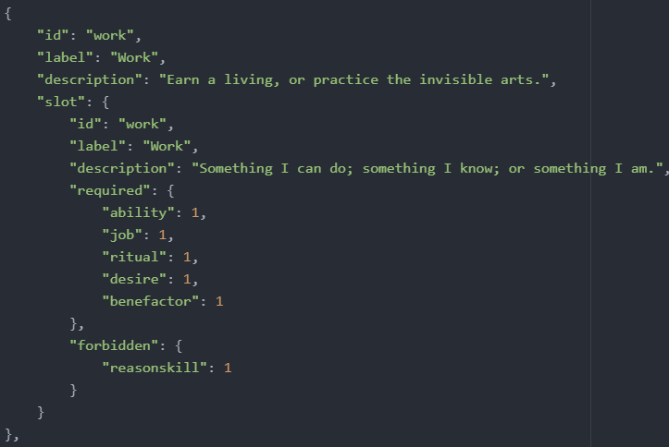

The work Verb

## 

## Legacies

### Description

Legacies are the beginning of our story. They tell us where we start, what we start with, and who we start as.

### Properties of Legacies

#### Legacy ID

| Property name | id |
| --- | --- |
| Explanation | The internal name of the Legacy. |
| Default value | No default value. **This property is mandatory.** |
| **Examples** | |
| Simple use of the property | {  "id": "myid"  } |

#### 

#### Label

| Property name | label |
| --- | --- |
| Explanation | The name of the Legacy displayed to the player in the UI. |
| Default value | "" |
| **Examples** | |
| Simple use of the property | {  "id": "myid",  "label": "Some label"  } |

#### Description

| Property name | description |
| --- | --- |
| Explanation | Text displayed in the Legacy Selection screen. |
| Default value | "" |
| **Examples** | |
| Simple use of the property | {     "id": "myid",     "description": "Some description" } |

#### Image ("image")

The image for the legacy displayed at the Legacy Selection screen

#### Starting Verb ("startingVerbId")

Legacies all start with only a single Verb on the board, as defined here.

#### Start Description ("startdescription")

Text displayed in the pop-up bubble at the bottom-center screen after starting the game.

#### Status Bar Elements ("statusbarelements")

A list of up to four Elements. These elements quantities and icons will be displayed at the bottom of the screen for the playthrough. The default layout, which is used by all legacies outside the Exile DLC includes Reason, Passion, Health, and Funds, while Exile Legacies use Obscurity, Comfort, Wounds, and Stolen Lifespan. When using statusbarelements, the icons for these elements must be copied into the statusbaricons folder in your mod's images folder.

#### Starting Cards ("effects")

A dictionary of the cards that the legacy starts with.

#### Exclude after Legacies (“excludesOnEnding”)

A list of the ids of the legacies that cannot be among the next proposed ones after this one.

#### New Start (“newstart”)

When true, the legacy icon is added to the area where the DLC legacies are and lets you start a new game by clicking on the legacy icon.

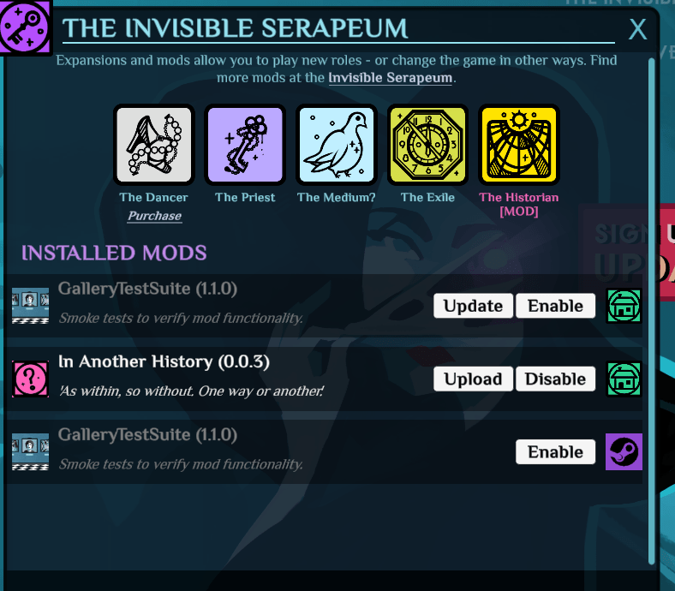

*Pictured: A mod (Historian) adding a legacy with “newstart”:true*

#### From Ending ("fromEnding")

Defining an ending here will make this legacy guaranteed to appear after that ending; unless that ending has more than three associated Legacies, in which case three associated Legacies will be chosen at random from these. Only one Ending can be defined; when one Legacy is desired to be available from more than one Ending, look-alike Legacies are often defined. An example of this is how there are two versions of each Apostle Legacy, one for its associated standard victory, and one for its associated victory with risen.

#### Available Without Ending Match ("availableWithoutEndingMatch")

This value is true for usual legacies. Setting it to false requires the predefined ending to be achieved for the legacy to appear. This is set to false for Apostle legacies.

#### 

#### 🐓 Use Checkpoints

| Property name | useCheckpoints |
| --- | --- |
| Explanation | This boolean property enables recipes to use a checkpoint system while this legacy is being played (see saveCheckpoint) |
| Default value | False (don't allow) |
| **Examples** | |
| Simple use of the property |  |

#### 

#### 🐓 Quotes

| Property name | quotes |
| --- | --- |
| Explanation | A list of strings. When this legacy is the one being played, one will be picked at random to be displayed during the quote screen. |
| Default value | [] (no custom quotes) |
| **Examples** | |
| Simple use of the property |  |

#### 

#### 🐓 Menu Visuals Override

| Property name | menuVisualsOverride |
| --- | --- |
| **Explanation** | |
| This property lets a legacy modify the main menu's background, when it is the current legacy being played. You can change:   * the sprites used * their position * the parent they're attached to * change some aspects of the particle emitters   Each element is named. You cannot add new elements.  The menuVisualsOverride is an object, with a lot of properties:   |  |  | | --- | --- | |  |  | |  |  |   To change the sprites: [TODO] | |
| Default value | {} (no changes to the visuals) |
| **Examples** | |
| Simple use of the property | {  "menuVisualsOverride": {  "mmBackgroundPeoplePosition": [  5,  0  ],  "mmBackgroundCharacterPosition": [  60,  -47  ],  "mmBackgroundEyeFlareRotationMinMax": [  0,  0  ],  "mmBackgroundEyeFlareParent": "SkyHolder",  "mmBackgroundEyeFlareColor": [  1.000,  1.000,  0.500,  1.000  ],  "mmBackgroundEyeFlarePosition": [  -79,  -27.6  ],  "mmBackgroundEyeEffectPosition": [  600,  -27.6  ],  "mmBackgroundEyeGlowParent": "Iris",  "mmBackgroundEyeGlowPosition": [  36,  -32  ],  "mmBackgroundEyeGlowColor": [  1.000,  0.600,  0.100,  0.700  ],  "mmBackgroundFloatingGlyphs2Parent": "Iris"  }  } |

### Examples

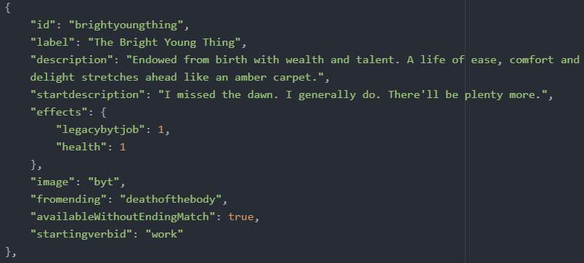

## 

## Endings

### Description

Endings are, obviously, the endings to our stories. They tell us what became of us.

### Properties of Endings

#### Ending ID

| Property name | id |
| --- | --- |
| Explanation | Internal name of the ending. |
| Default value | No default value. **This property is mandatory.** |
| **Examples** | |
| Simple use of the property | {  "id": "myid"  } |

#### 

#### Label

| Property name | label |
| --- | --- |
| Explanation | The name of the Ending as displayed on the Ending Screen to the player. |
| Default value | "" |
| **Examples** | |
| Simple use of the property | {  "id": "myid",  "label": "Some label"  } |

#### 

#### Description

| Property name | description |
| --- | --- |
| Explanation | The text shown to the player on the ending screen. |
| Default value | "" |
| **Examples** | |
| Simple use of the property | {  "id": "myid",  "description": "Some description"  } |

#### 

#### Achievements

| Property name | achievements |
| --- | --- |
| Explanation | This property defines the list of achievements to unlock when this ending is reached. |
| Default value | [] (no achievement unlocked) |
| **Examples** | |
| Simple use of the property |  |

1. Image ("image") - the image shown on the left of the ending screen
2. Ending Music? ("flavour") - accepts the Values "Grand", "Melancholy", and "Vile". This decides which music plays after getting the ending.
3. Ending Animation ("anim") - Decides the colour of the lights, and the cosmetics of the ending. Accepts "DramaticLight", "DramaticLightCool", and "DramaticLightEvil".

## Achievements

### Description

Achievements are a type of object defined like the others. Achievements are their own type, "achievements", and must be defined in their own files. They are unlocked via the "achievements" property in recipes, elements, and endings.

**Note that custom achievements do not appear in the Steam/GOG client and aren't tracked by it, they're handled exclusively inside Cultist Simulator.**

Taken from the modding readme:

| You can define custom achievements for the players to unlock. Custom achievements are displayed along with official ones in the dedicated overlay in the main menu.  Achievements are defined via JSONs in the same way as all other entities are defined: in a dedicated file/table annotated with an entity type - in our case "achievements". [...]  Label, icon and description govern an achievement's visible characteristics.  For icon and description, "locked" and "unlocked" suffixes determine, as it can be inferred, achievement's display while either in a locked or an unlocked state.  (but there's no "locked" and "unlocked" label - at least something should keep achievement's constancy throughout the states!).  Achievements share their icons with the Elements, and obey all the same rules of usage/loading/overriding/defaulting.  Locked icons are always displayed in grayscale, so keep that in mind. If no locked icon is specified, the unlocked one will be used.  HOWEVER that doesn't stand true for descriptions - if the locked description is empty, it's empty for good.  In case you want an achievement to have the same description both while locked and while unlocked, add a "singleDescription": true, and fill either of the descriptions.  "isHidden" property - for secretive folk (and is off by default).  It determines whether the locked achievement is visible in the menu. When it's not, its presence is opaquely hinted at by a "THERE'S AN X HIDDEN ACHIEVEMENTS IN THIS CATEGORY" message on a corresponding category's page.  [...] There are three ways to make the achievement unlock for the player.  Endings, Recipes, and Elements/Aspects can have an "Achievements" property. So every achievement id in this list gets unlocked once:  a) an Ending is reached.  b) a Recipe's warmup ends.  c) a card is touched by the player - and in this case, both card's own Element and *any of its aspects* - no matter native or mutated - contribute to the unlock.  When an achievement is unlocked, the in-game message is displayed, showing the achievement's label, icon and either "unlockMessage" (if that property is defined) or "descriptionUnlocked".  Unlocks are stored both locally and on either Steam/GOG Cloud Storage (if possible) - so they possess a known degree of persistence. |
| --- |

### Achievement categories

The list of the existing base game categories is:

* A_CATEGORY_DANCER (Dancer)
* A_CATEGORY_CS (Cultist Simulator)
* A_CATEGORY_EVERAFTER (Ever After)
* A_CATEGORY_PRIEST (Priest)
* A_CATEGORY_GHOUL (Ghoul)
* A_CATEGORY_EXILE (Exile)
* A_CATEGORY_MODS (Mod Content)

You can define custom achievement categories. To define a new achievements category, define an achievement with the isCategory property set at true. Its category icon will be defined by the iconUnlocked property.

### 

### File Example with an achievement and a custom achievement category

| {  "achievements": [  {  "id": "A_EXAMPLE",  "iconLocked": "corpse",  "iconUnlocked": "lunatic",  "label": "My First Hand-Made Achievement",  "descriptionLocked": "Not until there are enough here.",  "descriptionUnlocked": "I no longer have any idea what is real, and what is not.",  "unlockMessage": "This achievement doesn't exist, not in the game, anyway, and yet you've unlocked it! So many, many congratulations!",  "isHidden": true,  "category": "A_CATEGORY_EXAMPLE"  },  {  "id": "A_CATEGORY_EXAMPLE",  "isCategory": true,  "label": "My Very Own Achievements Category",  "iconUnlocked": "forge"  }  ]  } |
| --- |

#### 

### 

### Properties of Achievements

#### Achievement ID

| Property name | id |
| --- | --- |
| Explanation | Internal id of the achievement. Must be unique. |
| Default value | No default value. **This property is mandatory.** |
| **Examples** | |
| Simple use of the property | {  "id": "myid"  } |

#### 

#### Is Category

| Property name | isCategory |
| --- | --- |
| Explanation | If this property is set to true, then the achievement object being defined is an achievement category instead. |
| Default value | False (not a category) |
| **Examples** | |
| Simple use of the property | {  "isCategory": true  } |

#### 

#### Category

| Property name | category |
| --- | --- |
| Explanation | The category of this achievement. |
| Default value | No default value. **This property is mandatory.** |
| **Examples** | |
| Simple use of the property | {  "category": "A_CATEGORY_DANCER"  } |

#### 

#### Label

| Property name | label |
| --- | --- |
| Explanation | The name of the achievement |
| Default value | "" |
| **Examples** | |
| Simple use of the property | {  "label": "My achievement"  } |

#### 

#### Icon (Unlocked)

| Property name | iconUnlocked |
| --- | --- |
| Explanation | The icon displayed if the achievement is unlocked. The image file must be in images/elements if it's an achievement, images/aspects if it's a category. |
| Default value | "" (will display a default icon instead) |
| **Examples** | |
| Simple use of the property | {  "iconUnlocked": "myimagename"  } |

#### 

#### Description (Unlocked)

| Property name | descriptionUnlocked |
| --- | --- |
| Explanation | The description of the achievement, displayed if the achievement is unlocked. |
| Default value | No default value. **This property is mandatory.** |
| **Examples** | |
| Simple use of the property | {  "descriptionUnlocked": "This is the description."  } |

#### 

#### Icon (Locked)

| Property name | iconLocked |
| --- | --- |
| Explanation | The icon displayed if the achievement is locked. The image file must be in images/elements if it's an achievement, images/aspects if it's a category.  This icon is always displayed in greyscale. |
| Default value | "" (will display the unlocked icon instead) |
| **Examples** | |
| Simple use of the property | {  "iconUnlocked": "myimagename"  } |

#### 

#### Description (Locked)

| Property name | descriptionLocked |
| --- | --- |
| Explanation | The description of the achievement, displayed if the achievement is locked. |
| Default value | "" |
| **Examples** | |
| Simple use of the property | {  "descriptionLocked": "This is the description."  } |

#### 

#### 

#### Unlock Message

| Property name | unlockMessage |
| --- | --- |
| Explanation | Text displayed in the notification, when this achievement is unlocked. |
| Default value | "" |
| **Examples** | |
| Simple use of the property | {  "unlockMessage": "I have unlocked this achievement"  } |

#### 

#### Is Hidden

| Property name | isHidden |
| --- | --- |
| Explanation | Determines whether the locked achievement is visible in the menu. When it's not, its presence is opaquely hinted at by a "THERE'S AN X HIDDEN ACHIEVEMENTS IN THIS CATEGORY" message on a corresponding category's page. |
| Default value | "" |
| **Examples** | |
| Simple use of the property | {  "isHidden": true  } |

#### 

#### 

#### Single Description

| Property name | singleDescription |
| --- | --- |
| Explanation | If this is set to true, any of the two description properties can be filled instead of both and it will be used for both states (locked and unlocked). |
| Default value | false |
| **Examples** | |
| Simple use of the property | {  "singleDescription": true  } |

## Advanced Topic: Text Formatting

The label, startdescription, and description properties of objects support a number of advanced features to make them more dynamic or visually interesting.

### Text Formatting

The engine uses the Unity TMPro plugin for its texts. That means it supports all the markup tags defined [there](http://digitalnativestudios.com/textmeshpro/docs/rich-text/) to stylise the texts, but the base game only uses <i>*for italics*</i>, and <b>**for bold text**</b>.

### Inline Icons

TMPro also provides a <sprite> tag, allowing users to define icons and display them in a label or description. They're sometimes called "text sprites" or "inline icons". From a modding point of view, we can only use the icons the original developers defined.

The existing icons are these aspects: the nine principles, mortal, summoned, and follower.

|  | **You can define custom inline icons**  The Roost Machine allows you to define your own inline icons. You just have to add your icons in the images/textsprites folder. You can then insert them in texts using the <sprite> tag: <sprite name="myfile">  The image files shouldn't be bigger than the aspect images, and could probably be as low as 64x64 without the visuals suffering from it.  *What is this Bird?* |
| --- | --- |

### 

### Refinement Blocks

"Refinement blocks" are a syntax you can use in some texts, to have them display something based on a condition. The syntax is as follows:

| **@#**elementid1|the text to display**#**elementid2|other text to display**#**....**#**|default text**@** |
| --- |

* The block starts and ends with an **@** symbol
* The body of the block is made of parts, divided by **#** symbols
* Each part is made of an element id, a **|** separator, then the text to display when that element is present in the local scope (inside the verb).
* At the end, a default text can be defined, with a part that doesn't have an element id defined.

The first part to have a valid condition (presence of the element id) is selected to be displayed, and only one part is displayed at a time. Only one refinement block can be defined per label/startdescription/description property. Each part can only check for the presence of some element, not the amount (this is a Roost-specific feature).

|  | **Roost's specific additions**  As mentioned in the full reference, The Roost Machine allows you to:   * Define multiple refinement blocks in a property (but you can't nest them) * Define refinement blocks in multiple new properties like icon. * Define a minimum amount present in the refinement block syntax. See below:  | **@#**elementid1**|**amount**|**the text to display**#**...**#|**default text**@** | | --- | |
| --- | --- | --- |

### 

# 

# Tools and Resources

## Unofficial Discord

For modders coming from another source, the [Cultist Simulator Discord Server](https://discord.gg/ub2tE6Y) has a #mod-development channel where modders gather and help each other (they’re the main source of contributors for this guide).

## Frangiclave

[Frangiclave (https://uadaf.theevilroot.xyz/frangiclave/)](https://uadaf.theevilroot.xyz/frangiclave/) is an online reference of the game files, parsed and made easier to read. It is the best reference you can find if you cannot read the game files at this moment, or prefer a more readable way of reading the game files.

## Carcass Spark

[Carcass Spark (https://github.com/justastranger/CarcassSpark/releases)](https://github.com/justastranger/CarcassSpark/releases) is a visual tool to read the base content, create mods, and work on them. It is slower than writing them by hand, is easier to use, and prevents a lot of typos. You can also do a lot of things with it, like checking where a recipe/element is used, or directly see and edit the objects as JSON, which is a great way to check the syntax of something.

|  | **Warning**  The Carcass Spark tool isn't actively maintained anymore and is prone to bugs. |
| --- | --- |

## The Steam Workshop

[The Steam Workshop](https://steamcommunity.com/app/718670/workshop/) (called the “Sixth History”) is the official place where the mods are published.

## Assets

For reference, all the in-game assets can be found here, all with their filenames. (Thanks to Alex for uploading these.)  
<https://www.dropbox.com/sh/rs14yhtetpzszls/AADbrnTg1-BChKqLVvp2oTY5a?dl=0>

## Achieve Integrations

Achieve Integrations is a coremod with a number of compatibility fixes and modding tools, including the following:

* Slot overrides on Verbs, as well as some elements and recipes, to add generic allowed/forbidden aspects, enabling many mods to create elements for these slots without having to change the slots themselves.
* Changes to jobs and rites to allow finer control over what's allowed in them and when they can be executed.
* New aspects that exist to describe cults and rites, overhauling the recruit/promote/exalt processes to allow for new, custom cults.
* A new developer-only Verb and recipe (modded_xtrigger) that can be used to easily test XTriggers and inductions.

Information that follows is written to describe AchInt 2.5.0. Information here is likely to remain true, but may be made incomplete by future updates.

### Verbs

To allow an element to be placed in the main slot of a Verb, give it the aspect “modded_(Verb name)_allowed”, replacing (Verb name) with the name of the Verb. (In Exile, the name of the Verb is the name in the code, not the name in-game: relinquish, scout, send, travel, and use.)

To prevent an element from being placed in the main slot of a Verb, give it the aspect “modded_(Verb name)_forbidden”. (Be aware that giving the same card both the forbidden and allowed aspects of a Verb will cause the card to be forbidden.)

It is recommended that any mods adding their own Verbs go ahead and add aspects that match this pattern for their own Verbs, and configure those Verbs to allow/reject cards with those aspects accordingly.

### Rites and Rituals

New aspects that describe rites:

* modded_rite_accepts_promise: This is a rite that will accept a promise card instead of a desire card. In AchInt, this aspect is only given to the Rite Intercalate. If you create a new rite that accepts a promise, you are encouraged to give it this aspect.
* modded_rite_consumes_(resource): This is a rite that has a *consuming* slot for a given resource. Resources include follower, influence, ingredient, lore, and tool. For example, Rite of Rebel Striving (ritefollowerconsumetool) is given the modded_rite_consumes_tool aspect. When you create a rite with a consuming slot, or give a new consuming slot to a rite, you are encouraged to give the appropriate rite_consumes aspect to that rite.

New aspects that regulate rites:

* modded_rite_consumes_forbidden: An element with this aspect cannot be put into a *consuming* slot in a rite. For example, giving it to a Lore card will prevent that card from being used in Rite of the Watchman’s Sorrow, or Rite Intercalate.
* modded_rite_consumes_required: An element with this aspect cannot be put into a *non-*consuming slot in a rite. For example, giving it to a Lore card will prevent that card from being used in any rite *other than* Rite of the Watchman’s Sorrow or Rite Intercalate.
* modded_rite_desire_(allowed/forbidden): An element with this aspect (can/can’t) be placed in the *desire* slot of any rite.
* modded_rite_(resource)_(allowed/forbidden): Elements with the appropriate aspect for a given resource type (follower, influence, ingredient, lore, tool) can/can’t be placed into a rite slot that accepts that resource type. For example, a tool with modded_rite_tool_forbidden cannot be placed in the Tool slot of Rite Intercalate, Rite of the Watchman’s Sorrow, Rite of Rebel Striving, etc. Meanwhile, a Tool with modded_rite_influence_allowed can be placed into the Influence slot of any rite that accepts an influence.
* modded_rite_intercalate_forbidden: Elements with this aspect cannot be used in any slot of Rite Intercalate.
* modded_rite_intercalate_required: Elements with this aspect cannot be used in any rite *other than* Rite Intercalate.

New aspects that regulate rituals:

* modded_normal_rituals_forbidden: An element with this aspect cannot be used in *any* vanilla ritual that doesn’t involve a desire or promise. In other words, this aspect prevents summoning any vanilla spirit, creating a Risen, and enacting Forge’s Redemption, The End is Beautiful, Passion’s Gyre, and Reason’s Glory, as well as hints that relate to any of those.

### Cults

New aspects that describe cults (*and* enforce those descriptions!):

* cult_exalts_(principle): This aspect is given to cults capable of creating Exalts of the given Principle using the normal exaltation recipes. By giving a cult this aspect, you give it the ability to create Exalts of that type.
* cult_exalts_none: This aspect prevents cults from forming Exalts of any kind through the normal means. In addition, this aspect *implies* that the cult is incapable of forming Exalts through *any* means, though this trait is not enforced. If you want your cult to produce Exalts through other methods, it’s suggested that you give the cult the modded_cult_exalt_disciple_forbidden aspect instead (see next).
* modded_cult_exalt_disciple_forbidden: Elements with this aspect cannot be used in the *normal* process of promoting a disciple to exalt. This aspect can be applied to the cult, the associate, the ceremony, *or* the trappings, and the recipe will not engage.
* modded_cult_promote_believer_forbidden: Elements with this aspect cannot be used in the process of promoting a Believer to Disciple, akin to the way that the above aspect works with exalting Disciples.
* modded_cult_recruit_acquaintance_forbidden: Elements with this aspect cannot be used in the process of recruiting an acquaintance into a cult through the normal means.
* modded_cult_recruit_independent_forbidden: Elements with this aspect cannot be used in the process of recruiting an independent (Maverick) into a cult through the normal means.

## Online Translation Tool

[CS Online Translation Tool (https://genroa.github.io/Cultist-Simulator-Translation-Tool/)](https://genroa.github.io/Cultist-Simulator-Translation-Tool/) is a web app (that can be installed to be used offline) made to help translating CS content files. It is limited and can be laggy if the entire set of base game recipes is loaded, but “it works”.

|  | **Only Accepts Valid JSON**  Some game content files have JSON mistakes that most JSON parsers cannot read. You can fix them yourself, or use Carcass Spark to export a cleaned version of them (see the Tools menu of the software). |
| --- | --- |

# How Stuff works

## Followers

Required Aspects - followers need to belong to a uniqueness group. An aspect for uniqueness should be created. All elements of the follower should have their uniqueness group set to this aspect.

Additionally, you should create a hidden aspect for all of your followers that identifies them as yours, particularly if you want to make them romanceable. This aspect is used for recipes later to let your follower mod work with other follower mods. Give this aspect to all of your follower's elements. If you're adding more than one follower, use the same aspect for all of them.

Required Cards - Followers have a few different required elements that have to be configured in a certain way. All elements of all followers should be mortal. All elements of all followers should have an xtrigger on killmortal to become a corpse, and an xtrigger on derangemortal to become a lunatic.

* Acquaintance - should have the acquaintance aspect. Should have xtrigger on recruiting to become a believer, and an xtrigger on rebellion to become a renegade. This is the card that is put in the acquaintances deck. If you'd like your follower to be recruitable the normal way through the talk Verb, add them to this deck.
* Believer - should have the follower aspect. Believers conventionally have 2 of the aspect of their associated Principle. Romanceable followers have the desired lust aspect. Believers should have an xtrigger on promotiontodisciple to become their disciple element, an xtrigger on capturefollower to become their prisoner element, and should also have an xtrigger on rebellion to become their rival form.
* Disciple - should have the follower and disciple aspects, and conventionally have 5 of their associated Principle. If they have a secondary principle, it is conventionally set to 4. Romanceable followers should have the same lust aspect from their believer element. If your follower has an exalted element, the disciple should have the potential aspect, and an xtrigger for promoting: this xtrigger varies depending on their main Principle. Aside from exalting, all disciples should have an xtrigger on capturefollower to become prisoners, and an xtrigger on rebellion to become a stage 2 rival.
* Exalted - should have the follower, disciple, and exalted aspects. Conventionally, exalts have 10 of their main Principle, and 7 of their secondary if applicable. If romanceable, exalts should have the same lust aspect as they did as followers/disciples. Exalts have an xtrigger on rebellion to become Long in the Making.
* Prisoner - prisoners all have the prisoner aspect, and conventionally have three grail, three lantern, and three heart. For follower prisoners, they have five of their main Principle as well. If their main principle is Grail, Lantern, or Heart, the values are not added together, and are instead set to 5. Prisoners conventionally have a lifetime of 600, and decay to corpses.
* Rival - Rivals have 2 rival marks, the independent aspect, and the suspicious aspect. They have xtriggers on rival_promotion to become a Stage 2 rival, and on recruiting to become believers.
* Stage 2 rival - A promoted rival has 3 rival marks, as well as the independent, suspicious, and disciple aspects. Xtriggers on recruiting to become disciples, and on rival_promotion to become Long in the Making.
* Long in the Making - final form for rivals. They have 4 rival marks, and the independent, suspicious, and exalted aspects. Xtrigger on recruiting to become Exalt.

Required Recipes - Only romanceable followers need recipes. If your follower is not romanceable, you're done! Otherwise, you need to create some recipes, and modify some base game ones.

The base game recipes use description text with a refinement to choose text based on which follower you're speaking with. This text cannot be modified without replacing it entirely. If you replace it entirely, no other follower mods can be used at the same time as yours. So instead of overwriting the base game recipe descriptions, it is better to add equivalent recipes with your own descriptions.

Starting romance recipes

First are the romance recipes that occur from talktofollower to begin a romance. First, we create a lust recipe recipe that is exclusively for your followers. You will need a different recipe for every lust, and each lust has an associated location. Regardless, your recipe will look like the associated A_talktofollower_… recipe, except the ID must be different, and you will add a requirement for your oc aspect created at the start. Then you will modify the description text to have a section for each of your followers with this particular lust. (Note: if you have more than one follower, use the selective text syntax based on your follower's uniqueness aspect. This way it won't matter what promotion level your follower is at.) Just like the base recipe, you should link to L_talk_roseopportunity. Once the recipe is made, prepend it to talktofollower.

This next step isn't strictly necessary, but is good to do. You should modify the base game A_talktofollower_… recipe's requirements, adding the requirement to NOT having your oc aspect. Just in case.

Now we have to do a similar process, but for the applicable A_startrose_..._initiate recipes. Again, you'll make an identical recipe with a different ID, make it require your oc aspect, and give it different descriptive text. This recipe should then be prepended to alt for L_talk_roseopportunity. Then, once again, go add to the requirements for the base game A_startrose_..._initiate recipe to require not having your oc aspect.

Next, we need to add descriptive text for the season of ardours. We'll follow the same process of copying a base game recipe, but its easier since we only have to do it once for the last recipe. Find the applicable L_continuerose_..._success recipe. Make a recipe just like it, but with a different ID, a requirement for your oc aspect, and a description for your applicable followers. Prepend this recipe to the associated L_continuerose_… recipe. Then add to the requirements of the base game L_continuerose_..._success recipe to require not having your custom oc aspect.

Optionally, we can add our followers name to the romance ending recipes. The base game will automatically use "My lover" if none of the base game followers are in the recipe. If this is satisfactory, skip this section. If not, we use the previous method again.

First for the A_roseend_expulsion recipe. Make another recipe like it, with a different ID, modified flavour text, and a requirement for your custom oc aspect. This recipe must get prepended to the alternative recipes of L_activatejealousy with additional set to true, and an expulsion on follower with a limit of one. Once this is done, the base game L_roseend_expulsion recipe must be modified to add the requirement of not having your custom oc aspect. This step isn't optional here because we're dealing with additional recipes, and we don't want both executing.

Now we do this again for the L_roseend recipe. Change the ID, add a requirement for your custom oc aspect, and change the description text. Then prepend your recipe to linked for L_continuerose_chance, L_continuerose_enlightenment, L_continuerose_power, and L_continuerose_sensation. Optionally, modify the base game L_roseend recipe and add a requirement to NOT have your custom oc aspect.

Lastly, we just need to add an Ever After victory. First, we will set up the recipe that lets you achieve this victory. The base game has recipes for this called [name]victory. Make a recipe based off these ones, but with the requirement for your follower's uniqueness aspect. This recipe should then be prepended to belovedfarewell AND to belovedfarewelldream. Do this for each of your followers.

Now you just need to create an ending for your followers. Conventionally, Ever After endings use the Melancholy ending flavour and the DramaticLight animation.

## 

## Romance Categories

NOTE: While adding new romance options is possible, it is not currently possible to remove romance aspects from followers. New ones can still be added, but giving a follower two romance categories could cause minor issues.

Adding new romance Categories is easier than giving romance options to followers.

First, you need a hidden aspect for your romance type. This aspect should then be given to all applicable followers.

Next, you need to add a recipe to talktofollower. This recipe will functionally be identical to the other romance recipes, A_talktofollower_[location]_lust[type]. The start description should have refinement text with a description for each follower using this romance type. It should require your new romance aspect, and needs to require something else as well. Conventionally this is a location, it could be something else as well provided it doesn't interfere with other talktofollower recipes. This new recipe should be prepended as an alt recipe under talktofollower, and should link to L_talk_roseopportunity.

Our next recipe will be functionally equivalent to the base game A_startrose_[type]_initiate recipes. Ours should require a specific temptation. This should be done with an aspect that is present on all forms of the given temptation (ie A_startrose_power_initiate requires at least 1 powermark, this way all levels of ascensionpower will qualify). It should have refinement text in the description for all followers with this romance option. In addition to giving the romanticinterest aspect via mutation, this recipe conventionally gives an additional point in an associated principle via mutation as well.

Now that followers can start romance through the new option, we need to add a couple recipes to the season of ardours.

We will make a new recipe functionally identical to the L_continuerose_[type] recipes. Ours will require our new romance aspect. This new recipe will have a slot that needs to be filled. Funds and dread are used to end your romance, but anything besides those could be used to satisfy it. This recipe will have it's last alt recipe be the recipe we're creating next. This recipe should be prepended to the linked recipes in roserouter.

Our next recipe is a custom version of L_continuerose_[type]_success, and should require whatever we previously decided would be needed to satisfy the romance. Conventionally it gives contentment, and exhausts its required skill card. If using something different, you might consider exhausting or removing it. It has refinement text in the description for every associated follower.

## 

## Expeditions: Vaults & Obstacles

### Description

Vaults are places you can explore to do Expeditions. Expeditions are a gameplay system started when exploring with a vault card. Its main loop is :

* Vault specific start description
* Expedition loop
  + Send Funds or Followers
  + The next obstacle to encounter is selected (alt recipe). You can add Funds or Followers during this phase.
  + The obstacle is resolved (in the base-game, it is an aspect challenge)
* If there are no more obstacles, display the vault specific success description and draw rewards somehow (usually from a dedicated deck)
* If you don’t have followers left or no money anymore, the Expedition ends.

The Expedition System is structured this way:



*Blue: Recipes, Green: Alternative Recipes. Recipes with * are induced. Alternative recipes are stacked under their base recipe.*

### How to create new Vaults

Creating new vaults using existing obstacles is fairly easy.

|  | **Custom Obstacles**  Custom Obstacles are explained down below. This section only deals with the creation of new vaults. |
| --- | --- |

New vaults require:

* A new element, vault[tier][name], with aspects {"vault": 1, "location": 1, vault[tier]: 1}. It should have the same two slots as other vaults, ideally, but you can do whatever you want.
* A new recipe, vault[tier][name]_setup, with explorevault_expeditionbegun as a linked recipe.
  + It must have {"funds": 1, "follower": 1, [new vault element]: 1} as a requirement.
  + It must be craftable.
  + It should add in its effects the elements of the obstacles that will be encountered.
* A new recipe, vault[tier][name]_success. It should remove the vault card from the Verb, and spawn the "rewards". The base-game draws rewards from dedicated internal decks for each vault. (AchieveIntegrations changes that to external decks)
* Appending vault[tier][name]_success to explorevaultsuccess' linked recipes.

### How to create new Obstacles

To create new obstacles, you need:

* A new element, [obstaclename], describing the obstacle itself. Any vault using it must spawn it in its setup recipe's effects
* At least one new recipe, [obstaclename]_encounter. It must have {[obstaclename]: 1} in its requirements. Technically speaking, past this entry recipe, the obstacle logic could be anything, the expedition system doesn't care. It only eventually needs to go back to the tick recipe, and usually remove the [obstaclename] card from the Verb on success. The way base-game obstacles work is:
  + The encounter recipe and several alternative recipes are defined, all displaying the same slot (assistance, same slot as the tick recipe).
  + The alternative recipes are used when enough of some aspect is present in the Verb
  + The obstacle defines failure and success recipes. Failure recipes for guardians and perils have a 70% chance to call an alternative additional recipe, explorevault_casualty, which expels a follower. Curses have a 100% chance, on failure, to spawn a curse Verb, then route back to the tick recipe. Success recipes remove the obstacle from the Verb and then route to the tick recipe. Failure recipes leave the element to be faced again, with the exception of curses, which are removed on failure as well.
  + The encounter recipe always links to the failure recipe
  + The alternative recipes link to the success recipes, with a probability that depends on the quantity of aspect present (usually 30%, 70%. or 90%), and a link to the failure recipe
* Insert the encounter recipe in the explorevaulttick linked recipes list. You can append, prepend, or use listedit to insert at any position. You can also use listedit with a decimal value to insert between existing entries. (i.e. 3.5 to insert between the 3rd and 4th entry of a list)
* In the explorevaultsuccesslink recipe, either add {[obstaclename]: -1} to the requirements, or include one of the base-game obstacle categories (peril, guardian, seal, or curse), since the base-game groups are what the successlink recipe checks for.
* In the explorevaultfailure_nofunds and explorevaultfailure_nofollowers recipes, add {[obstaclename]: -10} (the value should be big enough to remove any instance of these obstacles from the Verb) to the effects. The base-game grouped obstacles by type, giving them an aspect, and uses it in these effects.

### How to create new Vault Tiers

TODO

# **On Book of Hours Modding**

**BOOK OF HOURS MODDING IS NOT OFFICIALLY SUPPORTED AND IS SUBJECT TO CHANGE**

That being said, there *are* currently two ways to make mods.

The first is to make DLL Mods, similar to Cultist Simulator, but using BepInEx as a modloader. You’ll need to make sure you don’t create any GameObjects before the quote screen, and enable the ‘HideManagerGameObject’ setting in BepInEx- this is because Book Of Hours, for some reason, deletes all GameObjects when the quote screen is shown, possibly as an anti-modding measure. For information on writing BepInEx plugins, see the [BepInEx documentation](https://docs.bepinex.dev/articles/dev_guide/plugin_tutorial/1_setup.html). Book of Hours uses Unity version 2022.3.9 and netstandard2.1 (you may need to use netstandard2.0 and change the target to 2.1 later). You’ll also need to use Harmony (included with BepInEx) to patch game functions. See the [Harmony docs](https://harmony.pardeike.net/articles/basics.html)

The second way is content modding, more familiar to Cultist Simulator modders. However, this has several major catches:

1. The codebase frequently changes. Expect your mods to break often. (This also applies to dll mods)
2. Modloading is disabled, and all mods must be put in the bhcontent/core folder directly. You can use prefixes like z_ and __ to control load order
3. Merge-overwriting, and by extension property operations, are disabled. You cannot edit existing objects and must redefine them completely; furthermore, it seems that the first loaded object with a given ID takes priority and future ones are ignored, so you’ll need to make sure your mod loads first if you want to replace anything.
4. The codebase has some changes from cultist simulator. Notably, AK seems to be removing most features that aren’t used by vanilla Book of Hours: the current list of changes is as follows.

Deleted features: maxexecutions, destruction purges, consuming slots, tablereqs

Renamed features:

* ‘requirements’ is now ‘reqs’
* ‘description’ is now ‘desc’

New features:

#### Xexts

| Property name | xexts |
| --- | --- |
| Explanation | Xexts are what’s used for the “I’m reading…” and “I’ve read” texts on books. Defining xexts on an element will cause the name of the aspect to be appended to the executing recipe description, and clicking on it will open a window with the text defined. |
| Default value | {} (No xexts) |
| **Examples** | |
| Simple use of the property | {  "xexts": {"forge":"This text will display when the forge aspect is present."}  } |

#### fx

| Property name | fx |
| --- | --- |
| Explanation | Fx is a mixed bag, and does many things. It’s an object containing string keys and number or string values, which are handled differently depending on what the key is.  Some examples:   * The “meta.setspeed” fx is used to reset the speed to x1 every daybreak * “music.[season]” is used to alter the music each season * fx can also show or hide ui elements, such as how reading your journal calls ui_wisdoms_or_world.show to show the wisdom wheel button |
| Default value | {} (no fx) |
| **Examples** | |
| Simple use of the property | {  "fx": {"weather.snow":0} //Sets the weather vfx to snowy  } |

#### Ambits

| Property name | ambits |
| --- | --- |
| Explanation | Ambits is a property on elements that’s used on skills to control what recipes are picked. In simple form, it’s a list of elements and aspects the game pretends are in the situation to make a list of recipes you could execute The engine picks the first element in the recipe with the ambits property (yes, this means only one element’s ambits will count, but vanilla BoH only uses it on skills so it doesn’t usually matter) and adds all the aspects and elements to an internal list. It then combines that list with what’s actually in the situation, and then adds every recipe whos reqs are met by the updated list, and can be executed in that situation, to the recipe picker. |
| Default value | {} (no ambits) |
| **Examples** | |
| Simple use of the property | {  "ambits": {"forge":99} //Pretend there’s 99 forge in this recipe when calculating what recipes to add to the recipe picker  } |

#### Ambittable

| Property name | ambittable |
| --- | --- |
| Explanation | Controls whether the recipe can show up in the recipe picker. |
| Default value | true |
| **Examples** | |
| Simple use of the property | {  "ambittable": false // Do not include this recipe in the recipe picker  } |